1. 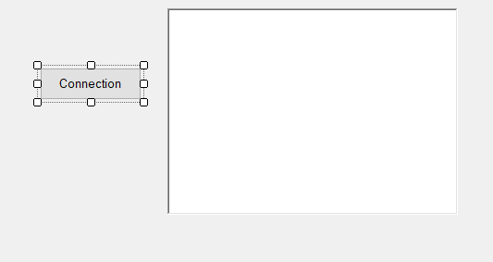Hava gəmisi koordinatlarının real zaman şəraitində əks olunması

1. using System;

2. using System.Collections.Generic;

3. using System.ComponentModel;

4. using System.Data;

5. using System.Drawing;

6. using System.Linq;

Timer var

7. using System.Text;

8. using System.Threading.Tasks;

9. using System.Windows.Forms;

10. using System.Runtime.InteropServices;

11. using LockheedMartin.Prepar3D.SimConnect;

12.

13. namespace Sual71

14. {

15. public partial class Form1 : Form

16. {

17. const int WM_USER_SIMCONNECT = 0x0402;

18. SimConnect simconnect = null;

19. public Form1()

20. {

21. InitializeComponent();

22. }

23.

24. private void Form1_Load(object sender, EventArgs e)

25. {

26.

27. }

28. enum DEFINITIONS

29. {

30. Struct1,

31. }

32.

33. enum DATA_REQUEST

34. {

35. REQUEST_1,

36. };

37.

38. [StructLayout(LayoutKind.Sequential, CharSet = CharSet.Ansi, Pack = 1)]

39. struct Struct1

40. {

41. public double latitude;

42. public double longitude;

43. public double altitude;

44. };

45. protected override void DefWndProc(ref Message m)

46. {

47. if (m.Msg == WM_USER_SIMCONNECT)

48. {

49. if (simconnect != null)

50. {

51. simconnect.ReceiveMessage();

52. }

53. }

54. else

55. {

56. base.DefWndProc(ref m);

57. }

58. }

59. private void initDataRequest()

60. {

61. try

62. {

63. simconnect.AddToDataDefinition(DEFINITIONS.Struct1, "Plane Latitude", "degrees", SIMCONNECT_DATATYPE.FLOAT64, 0.0f, SimConnect.SIMCONNECT_UNUSED);

64. simconnect.AddToDataDefinition(DEFINITIONS.Struct1, "Plane Longitude", "degrees", SIMCONNECT_DATATYPE.FLOAT64, 0.0f, SimConnect.SIMCONNECT_UNUSED);

65. simconnect.AddToDataDefinition(DEFINITIONS.Struct1, "Plane Altitude", "feet", SIMCONNECT_DATATYPE.FLOAT64, 0.0f, SimConnect.SIMCONNECT_UNUSED);

66. simconnect.RegisterDataDefineStruct<Struct1>(DEFINITIONS.Struct1);

67. simconnect.OnRecvSimobjectDataBytype += new SimConnect.RecvSimobjectDataBytypeEventHandler(simconnect_Onreceivedata);

68. }

69. catch (COMException ex)

70. {

71. richTextBox1.Text = "ex.Message";

72. }

73. }

74. void simconnect_Onreceivedata(SimConnect sender, SIMCONNECT_RECV_SIMOBJECT_DATA_BYTYPE data)

75. {

76. switch ((DATA_REQUEST)data.dwRequestID)

77. {

78. case DATA_REQUEST.REQUEST_1:

79. Struct1 s1 = (Struct1)data.dwData[0];

80. richTextBox1.Text += "Lat:" + s1.latitude + "\n";

81. richTextBox1.Text += "Lon:" + s1.longitude + "\n";

82. richTextBox1.Text += "Alt:" + s1.altitude + "\n";

83. break;

84.

85. default:

86. richTextBox1.Text += "Unknown request ID: " + data.dwRequestID;

87. break;

88. }

89. }

90. private void Connectbutton_Click(object sender, EventArgs e)

91. {

92. if (simconnect == null)

93. {

94. try

95. {

96. simconnect = new SimConnect("Managed Data Request", this.Handle, WM_USER_SIMCONNECT, null, 0);

97. initDataRequest();

98. richTextBox1.Text += "Connected\n\n";

99. }

100. catch (COMException ex)

101. {

102. richTextBox1.Text += "Unable to connect to Prepar3D:\n";

103. }

104. }

105. else

106. {

107. simconnect.Dispose();

108. simconnect = null;

109. richTextBox1.Text += "Connection closed \n\n";

110. }

111. timer1.Enabled = true;

112. }

113.

114. private void timer1_Tick(object sender, EventArgs e)

115. {

116. simconnect.RequestDataOnSimObjectType(DATA_REQUEST.REQUEST_1, DEFINITIONS.Struct1, 0, SIMCONNECT_SIMOBJECT_TYPE.USER);

117. }

118. }

119. }

120.

1. 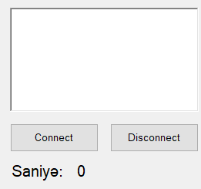Aviasimulyatora qoşulma və simulyatordan açılma periodunu hesablayan sayğacın hazırlanması (Time difference between connecting and disconnecting to Prepar3D)

1. using System;

2. using System.Collections.Generic;

3. using System.ComponentModel;

4. using System.Data;

5. using System.Drawing;

6. using System.Linq;

7. using System.Text;

8. using System.Threading.Tasks;

9. using System.Windows.Forms;

10. using LockheedMartin.Prepar3D.SimConnect;

11. using System.Runtime.InteropServices;

12.

13. namespace Sual72

14. {

15. public partial class Form1 : Form

16. {

17. const int WM_USER_SIMCONNECT = 0x0402;

18. SimConnect simconnect = null;

19. int i = 0;

20. public Form1()

21. {

22. InitializeComponent();

23. }

24.

25. private void Connectbutton_Click(object sender, EventArgs e)

26. {

27. if (simconnect == null)

28. {

29. try

30. {

31. simconnect = new SimConnect("Managed Data Request", this.Handle, WM_USER_SIMCONNECT, null, 0);

32. richTextBox1.Text = "Connected";

33. timer1.Enabled = true;

34. }

35. catch (COMException ex)

36. {

37. richTextBox1.Text = "Unable to connect to Prepar3D: \n\n" + ex.Message;

38. }

39. }

40. }

41. private void closeConnection()

42. {

43. if (simconnect != null)

44. {

45. simconnect.Dispose();

46. simconnect = null;

47. richTextBox1.Text = "Connection Closed\n";

48. }

49. }

50. private void Disconnectbutton_Click(object sender, EventArgs e)

51. {

52. closeConnection();

53. timer1.Enabled = false;

54. i = 0;

55. }

56.

57. private void timer1_Tick(object sender, EventArgs e)

58. {

59. label2.Text = i.ToString();

60. i++;

61. }

62. }

63. }

1. Danışıq əmrləri(Microsoft Speech) vastəsilə (left, right) hava gəmisi şturvalının sol və saga hərəkət etdirilməsi (Ailerons left , Ailerons right)

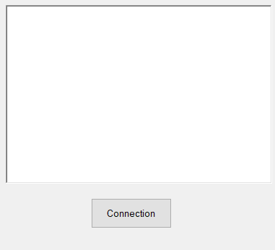 1. using System;

2. using System.Collections.Generic;

3. using System.ComponentModel;

4. using System.Data;

5. using System.Drawing;

6. using System.Linq;

7. using System.Text;

8. using System.Threading.Tasks;

9. using System.Windows.Forms;

10. using System.Runtime.InteropServices;

11. using LockheedMartin.Prepar3D.SimConnect;

12. using System.Speech.Recognition;

13. using System.Speech.Synthesis;

14.

15. namespace Sual73

16. {

17. public partial class Form1 : Form

18. {

19. const int WM_USER_SIMCONNECT = 0x0402;

20. SimConnect simconnect = null;

21. SpeechSynthesizer synth = new SpeechSynthesizer();

22. SpeechRecognitionEngine engine1 = new SpeechRecognitionEngine();

23. protected override void DefWndProc(ref Message m)

24. {

25. if (m.Msg == WM_USER_SIMCONNECT)

26. {

27. if (simconnect != null)

28. {

29. simconnect.ReceiveMessage();

30. }

31. }

32. else

33. {

34. base.DefWndProc(ref m);

35. }

36. }

37. enum EVENT_CTRL1

38. {

39. AILERONS_LEFT, AILERONS_RIGHT,

40. }

41. enum GROUP_IDS

42. {

43. GROUP_1,

44. }

45. public Form1()

46. {

47. InitializeComponent();

48. }

49. private void Form1_Load(object sender, EventArgs e)

50. {

51. engine1.SetInputToDefaultAudioDevice();

52. Choices ch1 = new Choices();

53. ch1.Add(new string[] { "right", "left" });

54. GrammarBuilder GB1 = new GrammarBuilder();

55. GB1.Append(ch1);

56. Grammar g = new Grammar(GB1);

57. engine1.LoadGrammarAsync(g);

58. engine1.SpeechRecognized += Engine1_SpeechRecognized;

59. engine1.RecognizeAsync(RecognizeMode.Multiple);

60. }

61. private void Engine1_SpeechRecognized(object sender, SpeechRecognizedEventArgs e)

62. {

63. string command = e.Result.Text;

64. if (e.Result.Text == "right")

65. {

66. simconnect.TransmitClientEvent(0, EVENT_CTRL1.AILERONS_RIGHT, 1, GROUP_IDS.GROUP_1, SIMCONNECT_EVENT_FLAG.GROUPID_IS_PRIORITY);

67. }

68. else if (e.Result.Text == "left")

69. {

70. simconnect.TransmitClientEvent(0, EVENT_CTRL1.AILERONS_LEFT, 1, GROUP_IDS.GROUP_1, SIMCONNECT_EVENT_FLAG.GROUPID_IS_PRIORITY);

71. }

72. }

73.

74. private void Connectbutton_Click(object sender, EventArgs e)

75. {

76. if (simconnect == null)

77. {

78. try

79. {

80. simconnect = new SimConnect("Managed Data Request", this.Handle, WM_USER_SIMCONNECT, null, 0);

81. CinitDataRequest();

82. richTextBox1.Text += "Connected";

83. }

84. catch (COMException ex)

85. {

86. richTextBox1.Text += "Unable to connect to Prepar3D: \n\n" + ex.Message;

87. }

88. }

89. else

90. {

91. simconnect.Dispose();

92. simconnect = null;

93. richTextBox1.Text += "Connection closed \n";

94. }

95. }

96. private void CinitDataRequest()

97. {

98. try

99. {

100. simconnect.MapClientEventToSimEvent(EVENT_CTRL1.AILERONS_LEFT, "AILERONS_LEFT");

101. simconnect.MapClientEventToSimEvent(EVENT_CTRL1.AILERONS_RIGHT, "AILERONS_RIGHT");

102. }

103. catch (COMException ex)

104. {

105. richTextBox1.Text = richTextBox1.Text + ex.Message;

106. }

107. }

108. }

109. }

110.

1. Danışıq ilə(Microsoft Speech) C# vastəsilə “connect” və “disconnect” əmrlərindən istifadə edərək, aviasimulyatorla qoşulmanın və əlaqənin kəsintisinin təmin edilməsi

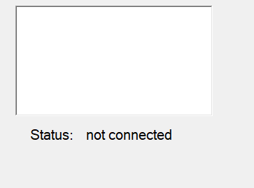 1. using System;

2. using System.Collections.Generic;

3. using System.ComponentModel;

4. using System.Data;

5. using System.Drawing;

6. using System.Linq;

7. using System.Text;

8. using System.Threading.Tasks;

9. using System.Windows.Forms;

10. using System.IO;

11. using System.Speech;

2 label var

12. using System.Speech.Synthesis;

13. using System.Speech.Recognition;

14. using LockheedMartin.Prepar3D.SimConnect;

15. using System.Runtime.InteropServices;

16.

17. namespace Sual74

18. {

19. public partial class Form1 : Form

20. {

21. const int WM_USER_SIMCONNECT = 0x0402;

22. SimConnect simconnect = null;

23. SpeechSynthesizer synth = new SpeechSynthesizer();

24. SpeechRecognitionEngine engine1 = new SpeechRecognitionEngine();

25. public Form1()

26. {

27. InitializeComponent();

28. }

29. protected override void DefWndProc(ref Message m)

30. {

31. if (m.Msg == WM_USER_SIMCONNECT)

32. {

33. if (simconnect != null)

34. {

35. simconnect.ReceiveMessage();

36. }

37. }

38. else

39. {

40. base.DefWndProc(ref m);

41. }

42. }

43. private void Form1_Load(object sender, EventArgs e)

44. {

45. engine1.SetInputToDefaultAudioDevice();

46. Choices ch1 = new Choices();

47. ch1.Add(new string[] { "Connect", "Disconnect" });

48. GrammarBuilder GB1 = new GrammarBuilder();

49. GB1.Append(ch1);

50. Grammar g = new Grammar(GB1);

51. engine1.LoadGrammarAsync(g);

52. engine1.SpeechRecognized += Engine1_SpeechRecognized;

53. engine1.RecognizeAsync(RecognizeMode.Multiple);

54. }

55. private void Engine1_SpeechRecognized(object sender, SpeechRecognizedEventArgs e)

56. {

57. string command = e.Result.Text;

58. if (e.Result.Text == "Connect")

59. {

60. if (simconnect == null)

61. {

62. try

63. {

64. simconnect = new SimConnect("Managed Data Request", this.Handle, WM_USER_SIMCONNECT, null, 0);

65. richTextBox1.Text = "Connected\n\n";

66. label2.Text = "Connected";

67. }

68. catch (COMException ex)

69. {

70. richTextBox1.Text = "Unable to connect to Prepar3D:\n";

71. label2.Text = "Not Connected";

72. }

73. }

74. }

75. else if (e.Result.Text == "Disconnect")

76. {

77. {

78. simconnect.Dispose();

79. simconnect = null;

80. richTextBox1.Text = "Connection closed \n\n";

81. label2.Text = "Disconnected";

82. }

83. }

84. synth.Speak(label2.Text);

85. synth.Dispose();

86. synth = new SpeechSynthesizer();

87. }

88. }

89. }

90.

1. Bu nömrəli sual yoxdur
2. 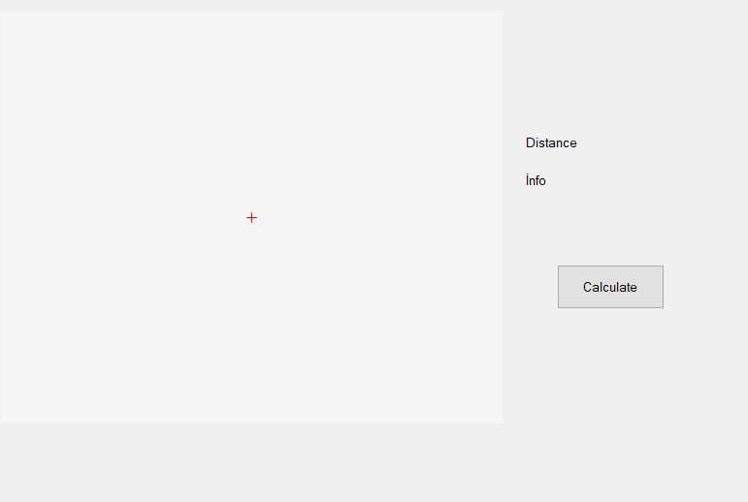Xəritə üzərində yerləşdirilmiş 2 nöqtə arasında məsafənin ölçülməsi

1. using System;

2. using System.Windows.Forms;

3. using GMap.NET;

4. using GMap.NET.MapProviders;

5. using GMap.NET.WindowsForms;

6. using GMap.NET.WindowsForms.Markers;

7.

8. namespace MapDistanceApp

9. {

10. public partial class Form1 : Form

11. {

12. GMapOverlay markersOverlay = new GMapOverlay("markers");

13. PointLatLng? point1 = null;

14. PointLatLng? point2 = null;

15. public Form1()

16. {

17. InitializeComponent();

18. InitializeMap();

19. }

20. private void InitializeMap()

21. {

22. gMapControl1.MapProvider = GMapProviders.GoogleMap;

23. gMapControl1.Position = new PointLatLng(40.4093, 49.8671); // Bakı koordinatları

24. gMapControl1.MinZoom = 5;

25. gMapControl1.MaxZoom = 100;

26. gMapControl1.Zoom = 10;

27. gMapControl1.ShowCenter = false;

28. gMapControl1.DragButton = MouseButtons.Left;

29.

30. // Maus klik hadisəsini əlavə edirik

31. gMapControl1.MouseClick += new MouseEventHandler(Map_MouseClick);

32. }

33. // Maus klik hadisəsi

34. private void Map_MouseClick(object sender, MouseEventArgs e)

35. {

36. if (e.Button == MouseButtons.Left)

37. {

38. PointLatLng point = gMapControl1.FromLocalToLatLng(e.X, e.Y);

39.

40. if (point1 == null)

41. {

42. point1 = point;

43. lblInfo.Text = $"Nöqtə 1: {point.Lat:F5}, {point.Lng:F5}";

44. AddMarker(point1.Value, GMarkerGoogleType.red_dot);

45. }

46. else if (point2 == null)

47. {

48. point2 = point;

49. lblInfo.Text += $"\nNöqtə 2: {point.Lat:F5}, {point.Lng:F5}";

50. AddMarker(point2.Value, GMarkerGoogleType.green_dot);

51. }

52. else

53. {

54. // İki nöqtə seçiləndən sonra sıfırlayırıq

55. point1 = point;

56. point2 = null;

57. markersOverlay.Markers.Clear();

58. lblInfo.Text = $"Nöqtə 1: {point.Lat:F5}, {point.Lng:F5}";

59. AddMarker(point1.Value, GMarkerGoogleType.red_dot);

60. }

61. }

62. }

63. private double CalculateDistance(PointLatLng point1, PointLatLng point2)

64. {

65. const double R = 6371; // Yerin radiusu (km)

66. double lat1 = point1.Lat * (Math.PI / 180);

67. double lat2 = point2.Lat * (Math.PI / 180);

68. double deltaLat = (point2.Lat - point1.Lat) * (Math.PI / 180);

69. double deltaLon = (point2.Lng - point1.Lng) * (Math.PI / 180);

70.

71. double a = Math.Sin(deltaLat / 2) * Math.Sin(deltaLat / 2) +

72. Math.Cos(lat1) * Math.Cos(lat2) *

73. Math.Sin(deltaLon / 2) * Math.Sin(deltaLon / 2);

74. double c = 2 * Math.Atan2(Math.Sqrt(a), Math.Sqrt(1 - a));

75.

76. return R * c; // Mesafe km olaraq qaytarılır

77. }

78. // Marker əlavə edən funksiya

79. private void AddMarker(PointLatLng point, GMarkerGoogleType markerType)

80. {

81. GMarkerGoogle marker = new GMarkerGoogle(point, markerType);

82. markersOverlay.Markers.Add(marker);

83. gMapControl1.Overlays.Clear();

84. gMapControl1.Overlays.Add(markersOverlay);

85. }

86. // Məsafəni hesablamaq

87. private void btnCalculate_Click(object sender, EventArgs e)

88. {

89. if (point1 != null && point2 != null)

90. {

91. double distance = CalculateDistance(point1.Value, point2.Value);

92. lblDistance.Text = $"Məsafə: {distance:F2} km";

93. }

94. else

95. {

96. MessageBox.Show("İki nöqtə seçilməlidir!");

97. }

98. }

99. private void gMapControl1_Load(object sender, EventArgs e)

100. {

101.

102. }

103. }

104. }

105.

1. Hava gəmisi şturvalının C# vastəsilə idarə edilməsi

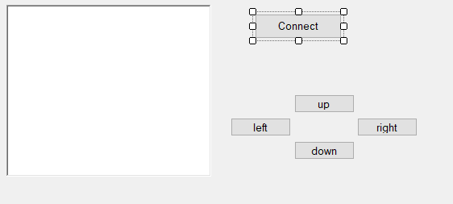 1. using System;

2. using System.Collections.Generic;

3. using System.ComponentModel;

4. using System.Data;

5. using System.Drawing;

6. using System.Linq;

7. using System.Runtime.InteropServices;

8. using System.Text;

9. using System.Threading.Tasks;

10. using System.Windows.Forms;

11. using System.Runtime.InteropServices;

12. using LockheedMartin.Prepar3D.SimConnect;

13.

14. namespace Sual77

15. {

16. public partial class Form1 : Form

17. {

18. const int WM_USER_SIMCONNECT = 0x0402;

19. SimConnect simconnect = null;

20. protected override void DefWndProc(ref Message m)

21. {

22. if (m.Msg == WM_USER_SIMCONNECT)

23. {

24. if (simconnect != null)

25. {

26. simconnect.ReceiveMessage();

27. }

28. }

29. else

30. {

31. base.DefWndProc(ref m);

32. }

33. }

34. enum EVENT_CTRL1

35. {

36. AILERONS_LEFT, AILERONS_RIGHT, ELEVATOR_DOWN, ELEVATOR_UP, THROTTLE_FULL,

37. }

38. enum GROUP_IDS

39. {

40. GROUP_1,

41. }

42. public Form1()

43. {

44. InitializeComponent();

45. }

46. private void Connectbutton_Click(object sender, EventArgs e)

47. {

48. if (simconnect == null)

49. {

50. try

51. {

52. simconnect = new SimConnect("Managed Data Request", this.Handle, WM_USER_SIMCONNECT, null, 0);

53. CinitDataRequest();

54. richTextBox1.Text += "Connected";

55. }

56. catch (COMException ex)

57. {

58. richTextBox1.Text += "Unable to connect to Prepar3D: \n\n" + ex.Message;

59. }

60. }

61. else

62. {

63. simconnect.Dispose();

64. simconnect = null;

65. richTextBox1.Text += "Connection closed \n";

66. }

67. }

68. private void CinitDataRequest()

69. {

70. try

71. {

72. simconnect.MapClientEventToSimEvent(EVENT_CTRL1.AILERONS_LEFT, "AILERONS_LEFT");

73. simconnect.MapClientEventToSimEvent(EVENT_CTRL1.AILERONS_RIGHT, "AILERONS_RIGHT");

74. simconnect.MapClientEventToSimEvent(EVENT_CTRL1.ELEVATOR_UP, "ELEVATOR_UP");

75. simconnect.MapClientEventToSimEvent(EVENT_CTRL1.ELEVATOR_DOWN, "ELEVATOR_DOWN");

76. }

77. catch (COMException ex)

78. {

79. richTextBox1.Text = richTextBox1.Text + ex.Message;

80. }

81. }

82. private void button2_Click(object sender, EventArgs e)

83. {

84. simconnect.TransmitClientEvent(0, EVENT_CTRL1.ELEVATOR_UP, 1, GROUP_IDS.GROUP_1, SIMCONNECT_EVENT_FLAG.GROUPID_IS_PRIORITY);

85. }

86. private void button5_Click(object sender, EventArgs e)

87. {

88. simconnect.TransmitClientEvent(0, EVENT_CTRL1.ELEVATOR_DOWN, 1, GROUP_IDS.GROUP_1, SIMCONNECT_EVENT_FLAG.GROUPID_IS_PRIORITY);

89. }

90. private void button3_Click(object sender, EventArgs e)

91. {

92. simconnect.TransmitClientEvent(0, EVENT_CTRL1.AILERONS_LEFT, 1, GROUP_IDS.GROUP_1, SIMCONNECT_EVENT_FLAG.GROUPID_IS_PRIORITY);

93. }

94. private void button4_Click(object sender, EventArgs e)

95. {

96. simconnect.TransmitClientEvent(0, EVENT_CTRL1.AILERONS_RIGHT, 1, GROUP_IDS.GROUP_1, SIMCONNECT_EVENT_FLAG.GROUPID_IS_PRIORITY);

97. }

98. }

99. }

100. }

101.

1. Prepar3D –də hava gəmisi mühərrikin C# vastəsilə işə salınması

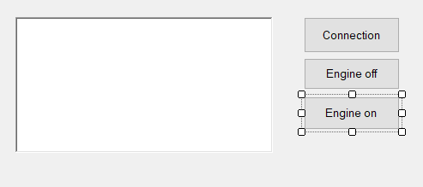 1. using System;

2. using System.Collections.Generic;

3. using System.ComponentModel;

4. using System.Data;

5. using System.Drawing;

6. using System.Linq;

7. using System.Text;

8. using System.Threading.Tasks;

9. using System.Windows.Forms;

10. using System.Runtime.InteropServices;

11. using LockheedMartin.Prepar3D.SimConnect;

12.

13. namespace Sual78

14. {

15. public partial class Form1 : Form

16. {

17. const int WM_USER_SIMCONNECT = 0x0402;

18. SimConnect simconnect = null;

19. public Form1()

20. {

21. InitializeComponent();

22. }

23. protected override void DefWndProc(ref Message m)

24. {

25. if (m.Msg == WM_USER_SIMCONNECT)

26. {

27. if (simconnect != null)

28. {

29. simconnect.ReceiveMessage();

30. }

31. }

32. else

33. {

34. base.DefWndProc(ref m);

35. }

36. }

37. enum EVENT_CTRL1

38. {

39. ENGINE_AUTO_START, ENGINE_AUTO_SHUTDOWN,

40. }

41. enum GROUP_IDS

42. {

43. GROUP_1,

44. }

45. private void Connectionbutton_Click(object sender, EventArgs e)

46. {

47. if (simconnect == null)

48. {

49. try

50. {

51. simconnect = new SimConnect("Managed Data Request", this.Handle, WM_USER_SIMCONNECT, null, 0);

52. CinitDataRequest();

53. richTextBox1.Text += "Connected";

54. }

55. catch (COMException ex)

56. {

57. richTextBox1.Text += "Unable to connect to Prepar3D: \n\n" + ex.Message;

58. }

59. }

60. else

61. {

62. simconnect.Dispose();

63. simconnect = null;

64. richTextBox1.Text += "Connection closed \n";

65. }

66. }

67. private void CinitDataRequest()

68. {

69. try

70. {

71.

72. simconnect.MapClientEventToSimEvent(EVENT_CTRL1.ENGINE_AUTO_START, "ENGINE_AUTO_START");

73. simconnect.MapClientEventToSimEvent(EVENT_CTRL1.ENGINE_AUTO_SHUTDOWN, "ENGINE_AUTO_SHUTDOWN");

74.

75. }

76. catch (COMException ex)

77. {

78. richTextBox1.Text = richTextBox1.Text + ex.Message;

79. }

80. }

81.

82. private void Engineoff_Click(object sender, EventArgs e)

83. {

84. simconnect.TransmitClientEvent(0, EVENT_CTRL1.ENGINE_AUTO_SHUTDOWN, 1, GROUP_IDS.GROUP_1, SIMCONNECT_EVENT_FLAG.GROUPID_IS_PRIORITY);

85. }

86.

87. private void Engineon_Click(object sender, EventArgs e)

88. {

89. simconnect.TransmitClientEvent(0, EVENT_CTRL1.ENGINE_AUTO_START, 1, GROUP_IDS.GROUP_1, SIMCONNECT_EVENT_FLAG.GROUPID_IS_PRIORITY);

90. }

91. }

92. }

1. Hava gəmisi koordinatlarının əldə edilməsi

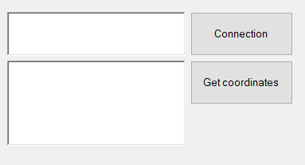 1. using System;

2. using System.Collections.Generic;

3. using System.ComponentModel;

4. using System.Data;

5. using System.Drawing;

6. using System.Linq;

7. using System.Text;

8. using System.Threading.Tasks;

9. using System.Windows.Forms;

10. using System.Runtime.InteropServices;

11. using LockheedMartin.Prepar3D.SimConnect;

12.

13. namespace Sual79

14. {

15. public partial class Form1 : Form

16. {

17. const int WM_USER_SIMCONNECT = 0x0402;

18. SimConnect simconnect = null;

19. enum DEFINITIONS

20. {

21. Struct1,

22. }

23.

24. enum DATA_REQUEST

25. {

26. REQUEST_1,

27. };

28. [StructLayout(LayoutKind.Sequential, CharSet = CharSet.Ansi, Pack = 1)]

29. struct Struct1

30. {

31. public double latitude;

32. public double longitude;

33. public double altitude;

34. };

35. protected override void DefWndProc(ref Message m)

36. {

37. if (m.Msg == WM_USER_SIMCONNECT)

38. {

39. if (simconnect != null)

40. {

41. simconnect.ReceiveMessage();

42. }

43. }

44. else

45. {

46. base.DefWndProc(ref m);

47. }

48. }

49. private void initDataRequest()

50. {

51. try

52. {

53. simconnect.AddToDataDefinition(DEFINITIONS.Struct1, "Plane Latitude", "degrees", SIMCONNECT_DATATYPE.FLOAT64, 0.0f, SimConnect.SIMCONNECT_UNUSED);

54. simconnect.AddToDataDefinition(DEFINITIONS.Struct1, "Plane Longitude", "degrees", SIMCONNECT_DATATYPE.FLOAT64, 0.0f, SimConnect.SIMCONNECT_UNUSED);

55. simconnect.AddToDataDefinition(DEFINITIONS.Struct1, "Plane Altitude", "feet", SIMCONNECT_DATATYPE.FLOAT64, 0.0f, SimConnect.SIMCONNECT_UNUSED);

56. simconnect.RegisterDataDefineStruct<Struct1>(DEFINITIONS.Struct1);

57. simconnect.OnRecvSimobjectDataBytype += new SimConnect.RecvSimobjectDataBytypeEventHandler(simconnect_Onreceivedata);

58. }

59. catch (COMException ex)

60. {

61. richTextBox2.Text = "ex.Message";

62. }

63. }

64. void simconnect_Onreceivedata(SimConnect sender, SIMCONNECT_RECV_SIMOBJECT_DATA_BYTYPE data)

65. {

66. switch ((DATA_REQUEST)data.dwRequestID)

67. {

68. case DATA_REQUEST.REQUEST_1:

69. Struct1 s1 = (Struct1)data.dwData[0];

70. richTextBox2.Text = "Lat:" + s1.latitude + "\n";

71. richTextBox2.Text += "Lon:" + s1.longitude + "\n";

72. richTextBox2.Text += "Alt:" + s1.altitude + "\n";

73. break;

74.

75. default:

76. richTextBox2.Text = "Unknown request ID: " + data.dwRequestID;

77. break;

78. }

79. }

80. public Form1()

81. {

82. InitializeComponent();

83. }

84.

85. private void Connectbutton_Click(object sender, EventArgs e)

86. {

87. if (simconnect == null)

88. {

89. try

90. {

91. simconnect = new SimConnect("Managed Data Request", this.Handle, WM_USER_SIMCONNECT, null, 0);

92. initDataRequest();

93. richTextBox1.Text = "Connected\n\n";

94. }

95. catch (COMException ex)

96. {

97. richTextBox1.Text = "Unable to connect to Prepar3D:\n";

98. }

99. }

100. else

101. {

102. simconnect.Dispose();

103. simconnect = null;

104. richTextBox1.Text = "Connection closed \n\n";

105. }

106. }

107.

108. private void button1_Click(object sender, EventArgs e)

109. {

110. simconnect.RequestDataOnSimObjectType(DATA_REQUEST.REQUEST_1, DEFINITIONS.Struct1, 0, SIMCONNECT_SIMOBJECT_TYPE.USER);

111. }

112. }

113. }

1. 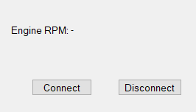Mooney Bravo tipli hava gəmisi mühərrikinin dövrlər sayının proqram təminatında əks olunması

1. using System;

2. using System.Runtime.InteropServices;

3. using System.Windows.Forms;

4. using LockheedMartin.Prepar3D.SimConnect;

5.

6. namespace Sual80

7. {

8. public partial class Form1 : Form

9. {

10. private SimConnect simConnect = null;

11. private const int WM_USER_SIMCONNECT = 0x0402;

12. private enum DataRequest

13. {

14. Request_1

15. }

16. private struct EngineData

17. {

18. public double rpm;

19. }

20. public Form1()

21. {

22. InitializeComponent();

23. }

24. // Connect to Prepar3D

25. private void connectButton_Click(object sender, EventArgs e)

26. {

27. try

28. {

29. simConnect = new SimConnect("Mooney Bravo RPM Monitor", Handle, WM_USER_SIMCONNECT, null, 0);

30.

31. // Subscribe to Engine RPM data

32. simConnect.AddToDataDefinition(DataRequest.Request_1, "GENERAL ENG RPM:1", "rpm",

33. SIMCONNECT_DATATYPE.FLOAT64, 0.0f, SimConnect.SIMCONNECT_UNUSED);

34.

35. simConnect.RegisterDataDefineStruct<EngineData>(DataRequest.Request_1);

36.

37. // Request data every second

38. simConnect.RequestDataOnSimObject(

39. DataRequest.Request_1,

40. DataRequest.Request_1,

41. SimConnect.SIMCONNECT_OBJECT_ID_USER,

42. SIMCONNECT_PERIOD.SECOND,

43. SIMCONNECT_DATA_REQUEST_FLAG.DEFAULT,

44. 0, 0, 0

45. );

46.

47. rpmLabel.Text = "Connected to Prepar3D";

48. simConnect.OnRecvSimobjectData += SimConnect_OnRecvSimobjectData;

49. }

50. catch (Exception ex)

51. {

52. rpmLabel.Text = $"Connection Error: {ex.Message}";

53. }

54. }

55. // Disconnect from Prepar3D

56. private void disconnectButton_Click(object sender, EventArgs e)

57. {

58. if (simConnect != null)

59. {

60. simConnect.Dispose();

61. simConnect = null;

62. rpmLabel.Text = "Disconnected";

63. }

64. }

65. // Handle incoming SimConnect messages

66. protected override void WndProc(ref Message m)

67. {

68. if (m.Msg == WM_USER_SIMCONNECT)

69. {

70. simConnect?.ReceiveMessage();

71. }

72. base.WndProc(ref m);

73. }

74. // Receive data from SimConnect

75. private void SimConnect_OnRecvSimobjectData(SimConnect sender, SIMCONNECT_RECV_SIMOBJECT_DATA data)

76. {

77. if (data.dwRequestID == (uint)DataRequest.Request_1)

78. {

79. EngineData engineData = (EngineData)data.dwData[0];

80. rpmLabel.Text = $"Engine RPM: {engineData.rpm:F1}";

81. }

82. }

83. private void connectButton_Click_1(object sender, EventArgs e)

84. {

85. try

86. {

87. simConnect = new SimConnect("Mooney Bravo RPM Monitor", Handle, WM_USER_SIMCONNECT, null, 0);

88. // Subscribe to Engine RPM data

89. simConnect.AddToDataDefinition(DataRequest.Request_1, "GENERAL ENG RPM:1", "rpm",

90. SIMCONNECT_DATATYPE.FLOAT64, 0.0f, SimConnect.SIMCONNECT_UNUSED);

91. simConnect.RegisterDataDefineStruct<EngineData>(DataRequest.Request_1);

92. // Request data every second

93. simConnect.RequestDataOnSimObject(

94. DataRequest.Request_1,

95. DataRequest.Request_1,

96. SimConnect.SIMCONNECT_OBJECT_ID_USER,

97. SIMCONNECT_PERIOD.SECOND,

98. SIMCONNECT_DATA_REQUEST_FLAG.DEFAULT,

99. 0, 0, 0

100. );

101. rpmLabel.Text = "Connected to Prepar3D";

102. simConnect.OnRecvSimobjectData += SimConnect_OnRecvSimobjectData;

103. }

104. catch (Exception ex)

105. {

106. rpmLabel.Text = $"Connection Error: {ex.Message}";

107. }

108. }

109. private void disconnectButton_Click_1(object sender, EventArgs e)

110. {

111. if (simConnect != null)

112. {

113. simConnect.Dispose();

114. simConnect = null;

115. rpmLabel.Text = "Disconnected";

116. }

117. }

118. }

119. }

1. Hava gəmisi müəyyən hündürlük yığdıqdan sonra, səs vastəsilə xəbərdarlıq verilməsi

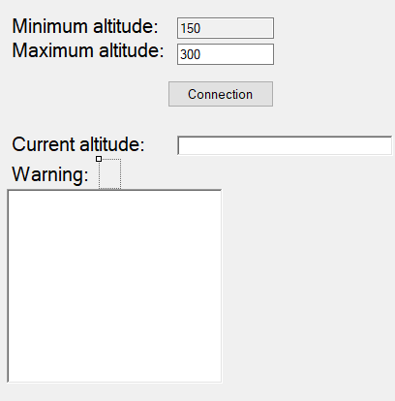 1. using System;

2. using System.Collections.Generic;

3. using System.ComponentModel;

4. using System.Data;

5. using System.Drawing;

6. using System.Linq;

7. using System.Text;

🡨Görünməz label var

8. using System.Threading.Tasks;

9. using System.Windows.Forms;

10. using System.Runtime.InteropServices;

11. using LockheedMartin.Prepar3D.SimConnect;

12. using System.Reflection.Emit;

13. using System.IO;

14. using System.Speech.Synthesis;

15.

16. namespace Sual81

17. {

18. public partial class Form1 : Form

19. {

20. const int WM_USER_SIMCONNECT = 0x0402;

21. SimConnect simconnect = null;

22. SpeechSynthesizer synth = new SpeechSynthesizer();

23. enum DEFINITIONS

24. {

25. Struct1,

26. }

27. enum DATA_REQUEST

28. {

29. REQUEST_1,

30. };

31. protected override void DefWndProc(ref Message m)

32. {

33. if (m.Msg == WM_USER_SIMCONNECT)

34. {

35. if (simconnect != null)

36. {

37. simconnect.ReceiveMessage();

38. }

39. }

40. else

41. {

42. base.DefWndProc(ref m);

43. }

44. }

45. public Form1()

46. {

47. InitializeComponent();

48. }

49. private void Form1_Load(object sender, EventArgs e)

50. {

51. }

52. private void Connectbutton_Click(object sender, EventArgs e)

53. {

54. if (simconnect == null)

55. {

56. try

57. {

58. simconnect = new SimConnect("Managed Data Request", this.Handle, WM_USER_SIMCONNECT, null, 0);

59. initDataRequest();

60. richTextBox1.Text = "Connected";

61. timer1.Enabled = true;

62. timer2.Enabled = true;

63. }

64. catch (COMException ex)

65. {

66. richTextBox1.Text += "Unable to connect to Prepar3D: \n\n" + ex.Message;

67. }

68. }

69. else

70. {

71. simconnect.Dispose();

72. simconnect = null;

73. richTextBox1.Text = "Connection closed \n";

74. }

75.

76. }

77. [StructLayout(LayoutKind.Sequential, CharSet = CharSet.Ansi, Pack = 1)]

78. struct Struct1

79. {

80. public double altitude;

81. };

82. private void initDataRequest()

83. {

84. try

85. {

86. simconnect.AddToDataDefinition(DEFINITIONS.Struct1, "PLANE ALTITUDE", "feet", SIMCONNECT_DATATYPE.FLOAT64, 0.0f, SimConnect.SIMCONNECT_UNUSED);

87.

88. simconnect.RegisterDataDefineStruct<Struct1>(DEFINITIONS.Struct1);

89. simconnect.OnRecvSimobjectDataBytype += new SimConnect.RecvSimobjectDataBytypeEventHandler(simconnect_Onreceivedata);

90. }

91. catch (COMException ex)

92. {

93. richTextBox2.Text = "ex.Message";

94. }

95. }

96. void simconnect_Onreceivedata(SimConnect sender, SIMCONNECT_RECV_SIMOBJECT_DATA_BYTYPE data)

97. {

98. switch ((DATA_REQUEST)data.dwRequestID)

99. {

100. case DATA_REQUEST.REQUEST_1:

101. Struct1 s1 = (Struct1)data.dwData[0];

102. richTextBox2.Text = s1.altitude.ToString();

103. if (s1.altitude <= 110)

104. {

105. label5.Text = " ";

106. }

107. else if (s1.altitude < Convert.ToDouble(textBox1.Text))

108. {

109. label5.Text = "Pull up";

110. }

111. else if ((s1.altitude > Convert.ToDouble(textBox1.Text)) && (s1.altitude < Convert.ToDouble(textBox2.Text)))

112. {

113. label5.Text = " ";

114. }

115. else if (s1.altitude > Convert.ToDouble(textBox2.Text))

116. {

117. label5.Text = "Pull down";

118. }

119. break;

120. default:

121. richTextBox1.Text = "Unknown request ID: " + data.dwRequestID;

122. break;

123. }

124. }

125. private void timer2_Tick(object sender, EventArgs e)

126. {

127. synth.SpeakAsync(label5.Text);

128. }

129.

130. private void timer1_Tick(object sender, EventArgs e)

131. {

132. simconnect.RequestDataOnSimObjectType(DATA_REQUEST.REQUEST_1, DEFINITIONS.Struct1, 0, SIMCONNECT_SIMOBJECT_TYPE.USER);

133. }

134. }

135. }

1. 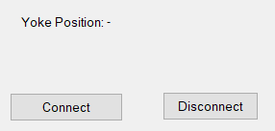Hava gəmisi şturvalının (sağ və ya sol) hansı mövqedə olmasının real zaman intervalında proqram təminatında əks olunması (label-da)

1. using System;

2. using System.Runtime.InteropServices;

3. using System.Windows.Forms;

4. using LockheedMartin.Prepar3D.SimConnect;

5.

6. namespace Sual82

7. {

8. public partial class Form1 : Form

9. {

10. private SimConnect simConnect = null;

11. private const int WM_USER_SIMCONNECT = 0x0402;

12. private enum DataRequest

13. {

14. Request_1

15. }

16. private struct YokePositionData

17. {

18. public double aileron; // Yoke-un sağa-sola dönüş açıları

19. }

20. public Form1()

21. {

22. InitializeComponent();

23. }

24. // Connect to Prepar3D

25. private void ConnectButton_Click(object sender, EventArgs e)

26. {

27. try

28. {

29. simConnect = new SimConnect("Yoke Position Monitor", Handle, WM_USER_SIMCONNECT, null, 0);

30.

31. // Aileron (yoke) pozisyonunu oxumaq üçün abunə oluruq

32. simConnect.AddToDataDefinition(DataRequest.Request_1, "AILERON POSITION", "position", SIMCONNECT_DATATYPE.FLOAT64, 0.0f, SimConnect.SIMCONNECT_UNUSED);

33. simConnect.RegisterDataDefineStruct<YokePositionData>(DataRequest.Request_1);

34.

35. // Hər saniyə məlumat sorğusu göndər

36. simConnect.RequestDataOnSimObject(

37. DataRequest.Request_1,

38. DataRequest.Request_1,

39. SimConnect.SIMCONNECT_OBJECT_ID_USER,

40. SIMCONNECT_PERIOD.SECOND,

41. SIMCONNECT_DATA_REQUEST_FLAG.DEFAULT,

42. 0, 0, 0

43. );

44.

45. yokePositionLabel.Text = "Connected to Prepar3D";

46. simConnect.OnRecvSimobjectData += SimConnect_OnRecvSimobjectData;

47. }

48. catch (Exception ex)

49. {

50. yokePositionLabel.Text = $"Connection Error: {ex.Message}";

51. }

52. }

53. // Disconnect from Prepar3D

54. private void DisconnectButton_Click(object sender, EventArgs e)

55. {

56. if (simConnect != null)

57. {

58. simConnect.Dispose();

59. simConnect = null;

60. yokePositionLabel.Text = "Disconnected";

61. }

62. }

63. // Handle incoming SimConnect messages

64. protected override void WndProc(ref Message m)

65. {

66. if (m.Msg == WM_USER_SIMCONNECT)

67. {

68. simConnect?.ReceiveMessage();

69. }

70. base.WndProc(ref m);

71. }

72. // Receive data from SimConnect

73. private void SimConnect_OnRecvSimobjectData(SimConnect sender, SIMCONNECT_RECV_SIMOBJECT_DATA data)

74. {

75. if (data.dwRequestID == (uint)DataRequest.Request_1)

76. {

77. YokePositionData yokeData = (YokePositionData)data.dwData[0];

78. yokePositionLabel.Text = $"Yoke Position: {yokeData.aileron:F2}";

79. }

80. }

81. private void Form1_Load(object sender, EventArgs e)

82. {

83.

84. }

85. private void yokePositionLabel_Click(object sender, EventArgs e)

86. {

87.

88. }

89. }

90. }

1. 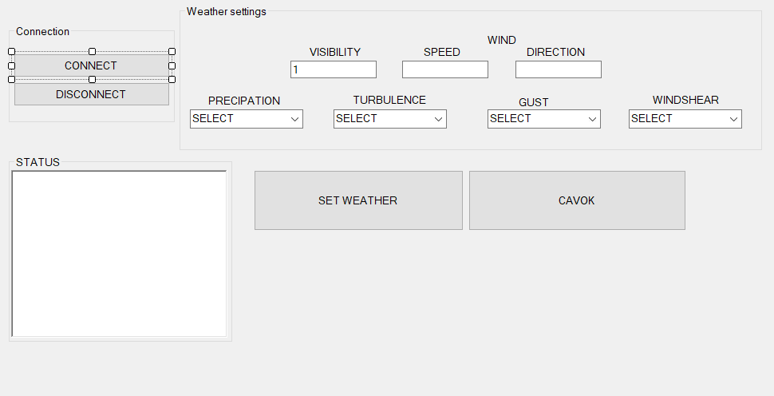Prepar3D aviasimulyatorunda hava şəraitinin C# vastəsilə təyin edilməsi

1. using System;

2. using System.Collections.Generic;

3. using System.ComponentModel;

4. using System.Data;

5. using System.Drawing;

6. using System.Linq;

7. using System.Runtime.InteropServices;

8. using System.Text;

9. using System.Threading.Tasks;

10. using System.Windows.Forms;

11. using LockheedMartin.Prepar3D.SimConnect;

12. using System.Runtime.InteropServices;

13. using System.Diagnostics;

14.

15. namespace Sual83

16. {

17. public partial class Form1 : Form

18. {

19. const int WM_USER_SIMCONNECT = 0x0402;

20. SimConnect simconnect = null;

21. public Form1()

22. {

23. InitializeComponent();

24. }

25.

26. private void Connectbutton_Click(object sender, EventArgs e)

27. {

28. if (simconnect == null)

29. {

30. try

31. {

32. simconnect = new SimConnect("Managed Data Request", this.Handle, WM_USER_SIMCONNECT, null, 0);

33. richTextBox1.Text += "Connected to Prepar3D\n";

34. }

35. catch (COMException ex)

36. {

37. richTextBox1.Text += Environment.NewLine + "Error - try again";

38. closeConnection();

39. }

40. }

41. }

42. private void Disconnectbutton_Click(object sender, EventArgs e)

43. {

44. closeConnection();

45. }

46. private void closeConnection()

47. {

48. if (simconnect != null)

49. {

50. simconnect.Dispose();

51. simconnect = null;

52. richTextBox1.Text = "Connection closed";

53. }

54. }

55. private void Cavokbutton_Click(object sender, EventArgs e)

56. {

57. simconnect.WeatherSetObservation(1, "GLOB CAVOK");

58. simconnect.WeatherSetModeCustom();

59. simconnect.WeatherSetModeGlobal();

60. }

61.

62. private void SetWeatherbutton_Click(object sender, EventArgs e)

63. {

64. if (wspeed.Text == "")

65. {

66. wspeed.Text = "0";

67. wdirection.Text = "0";

68. }

69. //Kill all on screen keyboards

70. Process[] oskProcessArray = Process.GetProcessesByName("TabTip");

71. foreach (Process onscreenProcess in oskProcessArray)

72. {

73. onscreenProcess.Kill();

74. }

75. string prec = "", turb = "", wshear = "G", gust = "", gustspeed = "";

76. //turbulence

77. if (comboBox_turb.Text == "NONE")

78. turb = "N";

79. if (comboBox_turb.Text == "LIGHT")

80. turb = "L";

81. if (comboBox_turb.Text == "MODERATE")

82. turb = "M";

83. if (comboBox_turb.Text == "HEAVY")

84. turb = "H";

85. if (comboBox_turb.Text == "SEVER")

86. turb = "S";

87. //precipitation

88. if (comboBox_prec.Text == "NONE")

89. prec = "";

90. if (comboBox_prec.Text == "SNOW")

91. prec = "+SN";

92. if (comboBox_prec.Text == "RAIN")

93. prec = "+RA";

94. //windshear

95. if (comboBox_wshear.Text == "NONE")

96. wshear = "G";

97. if (comboBox_wshear.Text == "MODERATE")

98. wshear = "M";

99. if (comboBox_wshear.Text == "STEEP")

100. wshear = "S";

101. if (comboBox_wshear.Text == "INSTANTANEOUS")

102. wshear = "T";

103. if (wdirection.Text.Length < 2 & wdirection.Text.Length > 0)

104. wdirection.Text = "00" + wdirection.Text;

105. if (wdirection.Text.Length < 3 & wdirection.Text.Length > 0)

106. wdirection.Text = "0" + wdirection.Text;

107. if (wspeed.Text.Length < 2 & wspeed.Text.Length > 0)

108. wspeed.Text = "0" + wspeed.Text;

109. simconnect.WeatherSetModeGlobal();

110. simconnect.WeatherSetObservation(1, "GLOB 030405Z" + " " + wdirection.Text + wspeed.Text + "KT&D5800" + turb + wshear + " " + visibilty.Text + "SM" + " " + prec + " " + "BKN262 M10/ 00 A2992");

111. }

112. }

113. }

1. Aviasimulyatorla əlaqə itdiyi zaman səs vastəsilə xəbərdalığın verilməsi (Attention! Disconnected from Prepar3D)

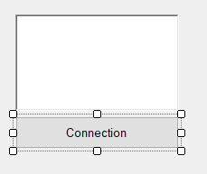 1. using System;

2. using System.Collections.Generic;

3. using System.ComponentModel;

4. using System.Data;

5. using System.Drawing;

6. using System.Linq;

7. using System.Text;

8. using System.Threading.Tasks;

9. using System.Windows.Forms;

10. using LockheedMartin.Prepar3D.SimConnect;

11. using System.Runtime.InteropServices;

12. using System.IO;

13. using System.Speech.Synthesis;

14. using System.Reflection.Emit;

15.

16. namespace Sual84

17. {

18. public partial class Form1 : Form

19. {

20. SimConnect simconnect = null;

21. const int WM_USER_SIMCONNECT = 0x0402;

22. SpeechSynthesizer synth = new SpeechSynthesizer();

23. public Form1()

24. {

25. InitializeComponent();

26. }

27.

28. private void button1_Click(object sender, EventArgs e)

29. {

30. if (simconnect == null)

31. {

32. try

33. {

34. simconnect = new SimConnect("Managed Data Request", this.Handle, WM_USER_SIMCONNECT, null, 0);

35. richTextBox1.Text = "Connected";

36. synth.SpeakAsync("Connected");

37.

38. }

39. catch (COMException ex)

40. {

41. richTextBox1.Text += "Unable to connect to Prepar3D: \n\n" + ex.Message;

42. synth.SpeakAsync("Attention! Unable to connect to Prepar3D");

43. }

44. }

45. else

46. {

47. simconnect.Dispose();

48. simconnect = null;

49. richTextBox1.Text = "Connection closed \n";

50. synth.SpeakAsync("Attention! Disconnected from Prepar3D");

51. }

52. }

53. private void closeConnection()

54. {

55. if (simconnect != null)

56. {

57. simconnect.Dispose();

58. simconnect = null;

59. richTextBox1.Text = richTextBox1.Text + "Connection Closed\n";

60. }

61. }

62. }

63. }

1. 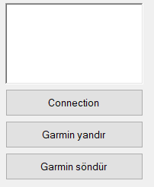C# vastəsilə Mooney Bravo modelində Garmin qurğusunun işə salınması

1. using System;

2. using System.Collections.Generic;

3. using System.ComponentModel;

4. using System.Data;

5. using System.Drawing;

6. using System.Linq;

7. using System.Text;

8. using System.Threading.Tasks;

9. using System.Windows.Forms;

10. using LockheedMartin.Prepar3D.SimConnect;

11. using System.Runtime.InteropServices;

12.

13. namespace Sual85

14. {

15. public partial class Form1 : Form

16. {

17. SimConnect simconnect = null;

18. const int WM_USER_SIMCONNECT = 0x0402;

19. enum EVENT_CTRL1

20. {

21. AVIONICS_MASTER,

22. }

23. enum GROUP_IDS

24. {

25. GROUP_1,

26. }

27. private void closeConnection()

28. {

29. if (simconnect != null)

30. {

31. simconnect.Dispose();

32. simconnect = null;

33. richTextBox1.Text = richTextBox1.Text + "Connection Closed\n";

34. }

35. }

36. public Form1()

37. {

38. InitializeComponent();

39. }

40.

41. private void Form1_Load(object sender, EventArgs e)

42. {

43.

44. }

45.

46. private void button1_Click(object sender, EventArgs e)

47. {

48. if (simconnect == null)

49. {

50. try

51. {

52. simconnect = new SimConnect("Sim1", this.Handle, WM_USER_SIMCONNECT, null, 0);

53. richTextBox1.Text = richTextBox1.Text + "Connected To P3D \n";

54. CinitDataRequest();

55. }

56. catch (COMException ex)

57. {

58. richTextBox1.Text = richTextBox1.Text + "Unable to connect to Prepar3D:\n\n" + ex.Message;

59. }

60. }

61. else

62. {

63. closeConnection();

64. }

65. }

66. private void CinitDataRequest()

67. {

68. try

69. {

70. simconnect.MapClientEventToSimEvent(EVENT_CTRL1.AVIONICS_MASTER, "AVIONICS_MASTER_SET");

71. }

72. catch (COMException ex)

73. {

74. richTextBox1.Text = richTextBox1.Text + ex.Message;

75. }

76. }

77. private void button3_Click(object sender, EventArgs e)

78. {

79. simconnect.TransmitClientEvent(0,EVENT_CTRL1.AVIONICS_MASTER, 1, GROUP_IDS.GROUP_1, SIMCONNECT_EVENT_FLAG.GROUPID_IS_PRIORITY);

80. }

81.

82. private void button2_Click(object sender, EventArgs e)

83. {

84. simconnect.TransmitClientEvent(0, EVENT_CTRL1.AVIONICS_MASTER, 0, GROUP_IDS.GROUP_1, SIMCONNECT_EVENT_FLAG.GROUPID_IS_PRIORITY);

85. }

86. }

87. }

1. Hava gəmisi müəyyən sürət həddini keçdikdən sonra , həddi keçmə anının (saat, dəqiqə və saniyə) verilənlər bazasında əks olunması
2. Prepar3D aviasimulyatorunda hava gəmisi koordinatlarının real zaman şəraitində C#-da əks olunması (Label-lar üzərində)

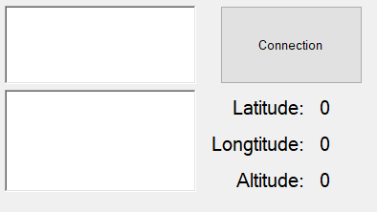 1. using System;

2. using System.Collections.Generic;

3. using System.ComponentModel;

4. using System.Data;

5. using System.Drawing;

6. using System.Linq;

7. using System.Text;

8. using System.Threading.Tasks;

9. using System.Windows.Forms;

10. using System.Runtime.InteropServices;

Timer var

11. using LockheedMartin.Prepar3D.SimConnect;

12.

13. namespace Sual87

14. {

15. public partial class Form1 : Form

16. {

17. const int WM_USER_SIMCONNECT = 0x0402;

18. SimConnect simconnect = null;

19. enum DEFINITIONS

20. {

21. Struct1,

22. }

23.

24. enum DATA_REQUEST

25. {

26. REQUEST_1,

27. };

28. [StructLayout(LayoutKind.Sequential, CharSet = CharSet.Ansi, Pack = 1)]

29. struct Struct1

30. {

31. public double latitude;

32. public double longitude;

33. public double altitude;

34. };

35. protected override void DefWndProc(ref Message m)

36. {

37. if (m.Msg == WM_USER_SIMCONNECT)

38. {

39. if (simconnect != null)

40. {

41. simconnect.ReceiveMessage();

42. }

43. }

44. else

45. {

46. base.DefWndProc(ref m);

47. }

48. }

49. private void initDataRequest()

50. {

51. try

52. {

53. simconnect.AddToDataDefinition(DEFINITIONS.Struct1, "Plane Latitude", "degrees", SIMCONNECT_DATATYPE.FLOAT64, 0.0f, SimConnect.SIMCONNECT_UNUSED);

54. simconnect.AddToDataDefinition(DEFINITIONS.Struct1, "Plane Longitude", "degrees", SIMCONNECT_DATATYPE.FLOAT64, 0.0f, SimConnect.SIMCONNECT_UNUSED);

55. simconnect.AddToDataDefinition(DEFINITIONS.Struct1, "Plane Altitude", "feet", SIMCONNECT_DATATYPE.FLOAT64, 0.0f, SimConnect.SIMCONNECT_UNUSED);

56. simconnect.RegisterDataDefineStruct<Struct1>(DEFINITIONS.Struct1);

57. simconnect.OnRecvSimobjectDataBytype += new SimConnect.RecvSimobjectDataBytypeEventHandler(simconnect_Onreceivedata);

58. }

59. catch (COMException ex)

60. {

61. richTextBox2.Text = "ex.Message";

62. }

63. }

64. void simconnect_Onreceivedata(SimConnect sender, SIMCONNECT_RECV_SIMOBJECT_DATA_BYTYPE data)

65. {

66. switch ((DATA_REQUEST)data.dwRequestID)

67. {

68. case DATA_REQUEST.REQUEST_1:

69. Struct1 s1 = (Struct1)data.dwData[0];

70. LatitudeLabel.Text = s1.latitude.ToString();

71. Longtitudelabel.Text = s1.longitude.ToString();

72. Altitudelabel.Text = s1.altitude.ToString();

73. break;

74.

75. default:

76. richTextBox2.Text = "Unknown request ID: " + data.dwRequestID;

77. break;

78. }

79. }

80. public Form1()

81. {

82. InitializeComponent();

83. }

84.

85. private void Connectbutton_Click(object sender, EventArgs e)

86. {

87. if (simconnect == null)

88. {

89. try

90. {

91. simconnect = new SimConnect("Managed Data Request", this.Handle, WM_USER_SIMCONNECT, null, 0);

92. initDataRequest();

93. richTextBox1.Text = "Connected\n\n";

94. timer1.Enabled = true;

95. }

96. catch (COMException ex)

97. {

98. richTextBox1.Text = "Unable to connect to Prepar3D:\n";

99. }

100. }

101. else

102. {

103. simconnect.Dispose();

104. simconnect = null;

105. richTextBox1.Text = "Connection closed \n\n";

106. timer1.Enabled = false;

107. }

108. }

109.

110. private void timer1_Tick(object sender, EventArgs e)

111. {

112. simconnect.RequestDataOnSimObjectType(DATA_REQUEST.REQUEST_1, DEFINITIONS.Struct1, 0, SIMCONNECT_SIMOBJECT_TYPE.USER);

113. }

114. }

115. }

116.

1. Hava gəmisi modeli və coğrafi koordinatlarının proqram təminatında əks olunması

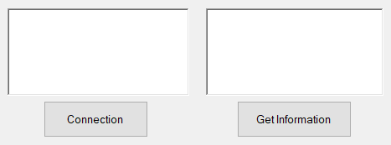 1. using System;

2. using System.Collections.Generic;

3. using System.ComponentModel;

4. using System.Data;

5. using System.Drawing;

6. using System.Linq;

7. using System.Text;

8. using System.Threading.Tasks;

9. using System.Windows.Forms;

10. using LockheedMartin.Prepar3D.SimConnect;

11. using System.Runtime.InteropServices;

12.

13. namespace Sual88

14. {

15. public partial class Form1 : Form

16. {

17. const int WM_USER_SIMCONNECT = 0x0402;

18. SimConnect simconnect = null;

19. enum DEFINITIONS

20. {

21. Struct1,

22. }

23.

24. enum DATA_REQUEST

25. {

26. REQUEST_1,

27. };

28. [StructLayout(LayoutKind.Sequential, CharSet = CharSet.Ansi, Pack = 1)]

29. struct Struct1

30. {

31. [MarshalAs(UnmanagedType.ByValTStr, SizeConst = 256)]

32. public String title;

33. public double latitude;

34. public double longitude;

35. public double altitude;

36. };

37. protected override void DefWndProc(ref Message m)

38. {

39. if (m.Msg == WM_USER_SIMCONNECT)

40. {

41. if (simconnect != null)

42. {

43. simconnect.ReceiveMessage();

44. }

45. }

46. else

47. {

48. base.DefWndProc(ref m);

49. }

50. }

51. private void initDataRequest()

52. {

53. try

54. {

55. simconnect.AddToDataDefinition(DEFINITIONS.Struct1, "Title", null, SIMCONNECT_DATATYPE.STRING256, 0.0f, SimConnect.SIMCONNECT_UNUSED);

56. simconnect.AddToDataDefinition(DEFINITIONS.Struct1, "Plane Latitude", "degrees", SIMCONNECT_DATATYPE.FLOAT64, 0.0f, SimConnect.SIMCONNECT_UNUSED);

57. simconnect.AddToDataDefinition(DEFINITIONS.Struct1, "Plane Longitude", "degrees", SIMCONNECT_DATATYPE.FLOAT64, 0.0f, SimConnect.SIMCONNECT_UNUSED);

58. simconnect.AddToDataDefinition(DEFINITIONS.Struct1, "Plane Altitude", "feet", SIMCONNECT_DATATYPE.FLOAT64, 0.0f, SimConnect.SIMCONNECT_UNUSED);

59.

60. simconnect.RegisterDataDefineStruct<Struct1>(DEFINITIONS.Struct1);

61. simconnect.OnRecvSimobjectDataBytype += new SimConnect.RecvSimobjectDataBytypeEventHandler(simconnect_Onreceivedata);

62. }

63. catch (COMException ex)

64. {

65. richTextBox2.Text = "ex.Message";

66. }

67. }

68. void simconnect_Onreceivedata(SimConnect sender, SIMCONNECT_RECV_SIMOBJECT_DATA_BYTYPE data)

69. {

70. switch ((DATA_REQUEST)data.dwRequestID)

71. {

72. case DATA_REQUEST.REQUEST_1:

73. Struct1 s1 = (Struct1)data.dwData[0];

74. richTextBox2.Text += "Title:" + s1.title + "\n";

75. richTextBox2.Text += "Lat:" + s1.latitude + "\n";

76. richTextBox2.Text += "Lon:" + s1.longitude + "\n";

77. richTextBox2.Text += "Alt:" + s1.altitude + "\n";

78. break;

79.

80. default:

81. richTextBox2.Text += "Unknown request ID: " + data.dwRequestID;

82. break;

83. }

84. }

85. public Form1()

86. {

87. InitializeComponent();

88. }

89.

90. private void Connectbutton_Click(object sender, EventArgs e)

91. {

92. if (simconnect == null)

93. {

94. try

95. {

96. simconnect = new SimConnect("Managed Data Request", this.Handle, WM_USER_SIMCONNECT, null, 0);

97. initDataRequest();

98. richTextBox1.Text = "Connected\n\n";

99. }

100. catch (COMException ex)

101. {

102. richTextBox1.Text = "Unable to connect to Prepar3D:\n";

103. }

104. }

105. else

106. {

107. simconnect.Dispose();

108. simconnect = null;

109. richTextBox1.Text = "Connection closed \n\n";

110. }

111. }

112.

113. private void Infobutton_Click(object sender, EventArgs e)

114. {

115. simconnect.RequestDataOnSimObjectType(DATA_REQUEST.REQUEST_1, DEFINITIONS.Struct1, 0, SIMCONNECT_SIMOBJECT_TYPE.USER);

116. }

117. }

118. }

1. 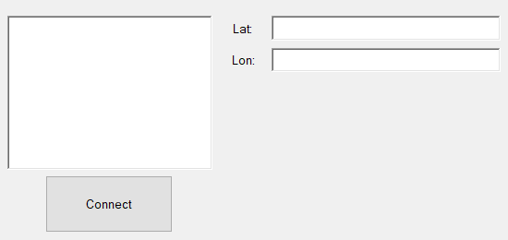Coğrafi koordinatların 10 saniyə intervalla verilənlər bazasında qeyd olunması

1. using System;

2. using System.Collections.Generic;

3. using System.ComponentModel;

4. using System.Data;

5. using System.Drawing;

6. using System.Linq;

2 timer var

7. using System.Text;

8. using System.Threading.Tasks;

9. using System.Windows.Forms;

10. using GMap.NET;

11. using GMap.NET.MapProviders;

12. using GMap.NET.WindowsForms;

13. using GMap.NET.WindowsForms.Markers;

14. using LockheedMartin.Prepar3D.SimConnect;

15. using System.Runtime.InteropServices;

16. using System.Data.OleDb;

17.

18. namespace Sual89

19. {

20. public partial class Form1 : Form

21. {

22. OleDbConnection con1 = new OleDbConnection();

23. string constr1 = "Provider=Microsoft.ACE.OLEDB.12.0;Data Source=C:\\Users\\Zenoxid\\Desktop\\Dərs\\VMS\\GPS.accdb";//baza adi ve location sizinki olsun

24. const int WM_USER_SIMCONNECT = 0x0402;

25. SimConnect simconnect = null;

26. enum DEFINITIONS

27. {

28. Struct1,

29. };

30. enum DATA_REQUESTS

31. {

32. Request_1,

33. };

34. [StructLayout(LayoutKind.Sequential, CharSet = CharSet.Ansi, Pack = 1)]

35. struct Struct1

36. {

37. public double latitude;

38. public double longitude;

39.

40. }

41. protected override void DefWndProc(ref Message m)

42. {

43. if (m.Msg == WM_USER_SIMCONNECT)

44. {

45. if (simconnect != null)

46. {

47. simconnect.ReceiveMessage();

48. }

49. }

50. else

51. {

52. base.DefWndProc(ref m);

53. }

54. }

55. private void initDataRequest()

56. {

57. try

58. {

59. simconnect.AddToDataDefinition(DEFINITIONS.Struct1, "Plane Latitude", "degrees", SIMCONNECT_DATATYPE.FLOAT64, 0.0f, SimConnect.SIMCONNECT_UNUSED);

60. simconnect.AddToDataDefinition(DEFINITIONS.Struct1, "Plane Longitude", "degrees", SIMCONNECT_DATATYPE.FLOAT64, 0.0f, SimConnect.SIMCONNECT_UNUSED);

61.

62. simconnect.RegisterDataDefineStruct<Struct1>(DEFINITIONS.Struct1);

63. simconnect.OnRecvSimobjectDataBytype += new SimConnect.RecvSimobjectDataBytypeEventHandler(simconnect_Onreceivedata);

64. }

65. catch (COMException ex)

66. {

67. richTextBox1.Text = "ex.Message";

68. }

69. }

70. public Form1()

71. {

72. InitializeComponent();

73. }

74.

75. private void Form1_Load(object sender, EventArgs e)

76. {

77.

78. }

79.

80. private void button1_Click(object sender, EventArgs e)

81. {

82. if (simconnect == null)

83. {

84. try

85. {

86. simconnect = new SimConnect("Managed Data Request", this.Handle, WM_USER_SIMCONNECT, null, 0);

87. initDataRequest();

88. richTextBox1.Text = "Connected";

89. con1 = new OleDbConnection(constr1);

90. con1.Open();

91. string sql2 = "DELETE FROM [Details]"; //Details cedvelin adidir

92. OleDbCommand com2 = new OleDbCommand(sql2, con1);

93. com2.ExecuteNonQuery();

94. timer1.Enabled = true;

95. timer2.Enabled = true;

96. }

97. catch (COMException ex)

98. {

99. richTextBox1.Text = "Unable to connect to Prepar3D: \n\n" + ex.Message;

100. }

101. }

102. else

103. {

104. simconnect.Dispose();

105. simconnect = null;

106. richTextBox1.Text = "Connection closed \n";

107. }

108. }

109.

110. private void timer2_Tick(object sender, EventArgs e)

111. {

112. con1 = new OleDbConnection(constr1);

113. con1.Open();

114. try

115. {

116. string details = "Insert into Details(Latitude, Longtitude) values(@lat, @long)"; //Latitude ve Longtitude sütun adi

117. OleDbCommand com1 = new OleDbCommand(details, con1);

118. com1.Parameters.Add("@lat", richTextBox2.Text);

119. com1.Parameters.Add("@long", richTextBox3.Text);

120. com1.ExecuteNonQuery();

121. MessageBox.Show("oldi");

122. }

123. catch (Exception ex)

124. {

125. MessageBox.Show(ex.Message);

126. }

127. }

128. void simconnect_Onreceivedata(SimConnect sender, SIMCONNECT_RECV_SIMOBJECT_DATA_BYTYPE data)

129. {

130. try

131. {

132. switch ((DATA_REQUESTS)data.dwRequestID)

133. {

134. case DATA_REQUESTS.Request_1:

135. Struct1 s1 = (Struct1)data.dwData[0];

136. richTextBox2.Text = s1.latitude.ToString();

137. richTextBox3.Text = s1.longitude.ToString();

138. break;

139. default:

140. richTextBox1.Text += "Unknown request ID: " + data.dwRequestID;

141. break;

142. }

143. }

144. catch (Exception ex)

145. {

146. MessageBox.Show(ex.Message);

147. }

148. }

149.

150. private void timer1_Tick(object sender, EventArgs e)

151. {

152. simconnect.RequestDataOnSimObjectType(DATA_REQUESTS.Request_1, DEFINITIONS.Struct1, 0, SIMCONNECT_SIMOBJECT_TYPE.USER);

153. }

154. }

155. }

156.

1. Hava gəmisi hündürlüyünün (həm barometric həm radiohündürlük) proqram təminatında əks olunması (label komponentlərində)

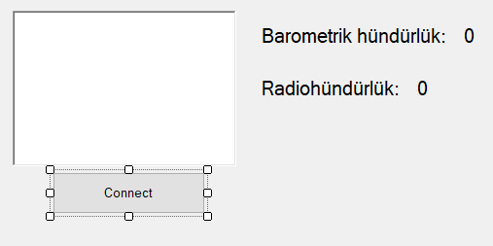 1. using System;

2. using System.Collections.Generic;

3. using System.ComponentModel;

4. using System.Data;

5. using System.Drawing;

6. using System.Linq;

7. using System.Text;

Timer var

8. using System.Threading.Tasks;

9. using System.Windows.Forms;

10. using System.Runtime.InteropServices;

11. using LockheedMartin.Prepar3D.SimConnect;

12.

13. namespace Sual90

14. {

15. public partial class Form1 : Form

16. {

17. const int WM_USER_SIMCONNECT = 0x0402;

18. SimConnect simconnect = null;

19. enum DEFINITIONS

20. {

21. Struct1,

22. }

23. enum DATA_REQUEST

24. {

25. REQUEST_1,

26. }

27. protected override void DefWndProc(ref Message m)

28. {

29. if (m.Msg == WM_USER_SIMCONNECT)

30. {

31. if (simconnect != null)

32. {

33. simconnect.ReceiveMessage();

34. }

35. }

36. else

37. {

38. base.DefWndProc(ref m);

39. }

40. }

41. public Form1()

42. {

43. InitializeComponent();

44. }

45. private void button1_Click(object sender, EventArgs e)

46. {

47. if (simconnect == null)

48. {

49. try

50. {

51. simconnect = new SimConnect("Altitude Display", this.Handle, WM_USER_SIMCONNECT, null, 0);

52. initDataRequest();

53. richTextBox1.Text = "Connected to Prepar3D";

54. timer1.Enabled = true;

55. }

56. catch (COMException ex)

57. {

58. richTextBox1.Text += "Unable to connect to Prepar3D: \n\n" + ex.Message;

59. }

60. }

61. else

62. {

63. simconnect.Dispose();

64. simconnect = null;

65. richTextBox1.Text = "Connection closed.";

66. }

67. }

68. [StructLayout(LayoutKind.Sequential, CharSet = CharSet.Ansi, Pack = 1)]

69. struct Struct1

70. {

71. public double BarometricAltitude;

72. public double RadioAltitude;

73. };

74. private void initDataRequest()

75. {

76. try

77. {

78. simconnect.AddToDataDefinition(DEFINITIONS.Struct1, "PLANE ALTITUDE", "feet", SIMCONNECT_DATATYPE.FLOAT64, 0.0f, SimConnect.SIMCONNECT_UNUSED); // Barometrik hündürlük

79. simconnect.AddToDataDefinition(DEFINITIONS.Struct1, "RADIO HEIGHT", "feet", SIMCONNECT_DATATYPE.FLOAT64, 0.0f, SimConnect.SIMCONNECT_UNUSED); // Radio hündürlük

80.

81. simconnect.RegisterDataDefineStruct<Struct1>(DEFINITIONS.Struct1);

82. simconnect.OnRecvSimobjectDataBytype += new SimConnect.RecvSimobjectDataBytypeEventHandler(simconnect_Onreceivedata);

83. }

84. catch (COMException ex)

85. {

86. richTextBox1.Text += "Data definition error: " + ex.Message;

87. }

88. }

89.

90. private void timer1_Tick(object sender, EventArgs e)

91. {

92. simconnect.RequestDataOnSimObjectType(DATA_REQUEST.REQUEST_1, DEFINITIONS.Struct1, 0, SIMCONNECT_SIMOBJECT_TYPE.USER);

93. }

94. void simconnect_Onreceivedata(SimConnect sender, SIMCONNECT_RECV_SIMOBJECT_DATA_BYTYPE data)

95. {

96. switch ((DATA_REQUEST)data.dwRequestID)

97. {

98. case DATA_REQUEST.REQUEST_1:

99. Struct1 s1 = (Struct1)data.dwData[0];

100. label2.Text = s1.BarometricAltitude.ToString();

101. label4.Text = s1.RadioAltitude.ToString();

102. break;

103. default:

104. richTextBox1.Text = "Unknown request ID: " + data.dwRequestID;

105. break;

106. }

107. }

108. }

109. }

110.

1. 2 saniyə intervalla , Monney Bravo modelində “Throttle” qurğusunun basılma dərəcəsinin 1 % artırılması (75% olduqda avtomatik dayanır)

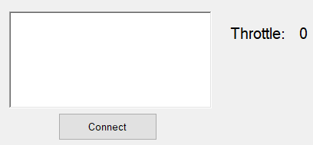 1. using System;

2. using System.Collections.Generic;

3. using System.ComponentModel;

4. using System.Data;

5. using System.Drawing;

6. using System.Linq;

7. using System.Text;

8. using System.Threading.Tasks;

9. using System.Windows.Forms;

10. using System.Runtime.InteropServices;

11. using LockheedMartin.Prepar3D.SimConnect;

12.

13. namespace Sual91

14. {

15. public partial class Form1 : Form

16. {

17. double currentThrottle = 0;

18. const int WM_USER_SIMCONNECT = 0x0402;

19. SimConnect simconnect = null;

20. enum DEFINITIONS

21. {

22. Struct1,

23. }

24. enum DATA_REQUEST

25. {

26. REQUEST_1,

27. }

28. enum EVENT_IDS

29. {

30. THROTTLE_INCR,

31. }

32. enum GROUP_IDS

33. {

34. GROUP_1,

35. }

36. [StructLayout(LayoutKind.Sequential, CharSet = CharSet.Ansi, Pack = 1)]

37. struct Struct1

38. {

39. public double ThrottlePosition; // Throttle dəyəri (0-100%)

40. }

41.

42. protected override void DefWndProc(ref Message m)

43. {

44. if (m.Msg == WM_USER_SIMCONNECT)

45. {

46. if (simconnect != null)

47. {

48. simconnect.ReceiveMessage();

49. }

50. }

51. else

52. {

53. base.DefWndProc(ref m);

54. }

55. }

56. public Form1()

57. {

58. InitializeComponent();

59. }

60.

61. private void button1_Click(object sender, EventArgs e)

62. {

63. if (simconnect == null)

64. {

65. try

66. {

67. simconnect = new SimConnect("Throttle Control", this.Handle, WM_USER_SIMCONNECT, null, 0);

68. CinitDataRequest();

69. initThrottleRequest();

70. richTextBox1.Text = "Connected to Prepar3D";

71. timer1.Enabled = true;

72. currentThrottle = 0;

73. }

74. catch (COMException ex)

75. {

76. richTextBox1.Text += "Unable to connect to Prepar3D: \n\n" + ex.Message;

77. }

78. }

79. else

80. {

81. timer1.Enabled = false;

82. simconnect.Dispose();

83. simconnect = null;

84. richTextBox1.Text = "Connection closed.";

85. }

86. }

87. private void initThrottleRequest()

88. {

89. try

90. {

91. simconnect.AddToDataDefinition(DEFINITIONS.Struct1,"GENERAL ENG THROTTLE LEVER POSITION:1","percent",SIMCONNECT_DATATYPE.FLOAT64,0.0f,SimConnect.SIMCONNECT_UNUSED);

92. simconnect.RegisterDataDefineStruct<Struct1>(DEFINITIONS.Struct1);

93. simconnect.RequestDataOnSimObject(DATA_REQUEST.REQUEST_1,DEFINITIONS.Struct1,SimConnect.SIMCONNECT_OBJECT_ID_USER,SIMCONNECT_PERIOD.SIM_FRAME,SIMCONNECT_DATA_REQUEST_FLAG.DEFAULT,0,0,0);

94. simconnect.OnRecvSimobjectData += new SimConnect.RecvSimobjectDataEventHandler(simconnect_OnThrottleReceived);

95. }

96. catch (COMException ex)

97. {

98. richTextBox1.Text += "Throttle oxuma xəta: " + ex.Message;

99. }

100. }

101. private void simconnect_OnThrottleReceived(SimConnect sender, SIMCONNECT_RECV_SIMOBJECT_DATA data)

102. {

103. if ((DATA_REQUEST)data.dwRequestID == DATA_REQUEST.REQUEST_1)

104. {

105. // Məlumatı oxuyur

106. Struct1 throttleData = (Struct1)data.dwData[0];

107. // Throttle dəyərini double formatında yazır

108. label2.Text = throttleData.ThrottlePosition.ToString();

109. double a = throttleData.ThrottlePosition;

110. }

111. }

112.

113.

114. private void CinitDataRequest()

115. {

116. try

117. {

118. simconnect.MapClientEventToSimEvent(EVENT_IDS.THROTTLE_INCR, "THROTTLE_INCR");

119. }

120. catch (COMException ex)

121. {

122. richTextBox1.Text += "Xəta: " + ex.Message;

123. }

124. }

125. private void timer1_Tick(object sender, EventArgs e)

126. {

127. if (simconnect == null)

128. {

129. timer1.Enabled = false;

130. MessageBox.Show("SimConnect bağlantısı yoxdur. Zəhmət olmasa əvvəlcə bağlanın.");

131. return;

132. }

133. string a = label2.Text;

134. if ( Convert.ToDouble(a) >= 75)

135. {

136. timer1.Enabled = false;

137. MessageBox.Show("Throttle 75%-ə çatdı");

138. return;

139. }

140. else

141. {

142. simconnect.TransmitClientEvent(0, EVENT_IDS.THROTTLE_INCR, 1, GROUP_IDS.GROUP_1, SIMCONNECT_EVENT_FLAG.GROUPID_IS_PRIORITY);

143. }

144.

145. }

146.

147. }

148. }

149.

1. Prepar3D aviasimulyatoru ilə C# arasında interfeysin qurulması

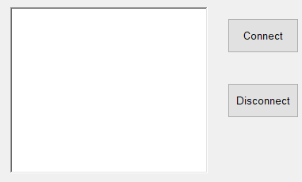 1. using System;

2. using System.Collections.Generic;

3. using System.ComponentModel;

4. using System.Data;

5. using System.Drawing;

6. using System.Linq;

7. using System.Text;

8. using System.Threading.Tasks;

9. using System.Windows.Forms;

10. using LockheedMartin.Prepar3D.SimConnect;

11. using System.Runtime.InteropServices;

12.

13. namespace Sual92

14. {

15. public partial class Form1 : Form

16. {

17. SimConnect simconnect = null;

18. const int WM_USER_SIMCONNECT = 0x0402;

19. public Form1()

20. {

21. InitializeComponent();

22. }

23.

24. private void Connectbutton_Click(object sender, EventArgs e)

25. {

26. if (simconnect == null)

27. {

28. try

29. {

30. simconnect = new SimConnect("Sim1", this.Handle, WM_USER_SIMCONNECT, null, 0);

31. richTextBox1.Text = richTextBox1.Text + "Connected To P3D \n";

32.

33. }

34. catch (COMException ex)

35. {

36. richTextBox1.Text = richTextBox1.Text + "Unable to connect to Prepar3D:\n\n" + ex.Message;

37. }

38. }

39. else

40. {

41. closeConnection();

42. }

43. }

44. private void closeConnection()

45. {

46. if (simconnect != null)

47. {

48. simconnect.Dispose();

49. simconnect = null;

50. richTextBox1.Text = richTextBox1.Text + "Connection Closed\n";

51. }

52. }

53.

54. private void Disconnectbutton_Click(object sender, EventArgs e)

55. {

56. closeConnection();

57. }

58. }

59. }

60.

1. 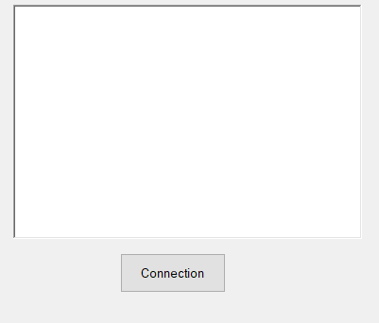Danışıq əmrləri(Microsoft Speech) vastəsilə (up, down) hava gəmisi şturvalının yuxarı və aşağı hərəkət etdirilməsi (Elevator up , Elevator down)

1. using System;

2. using System.Collections.Generic;

3. using System.ComponentModel;

4. using System.Data;

5. using System.Drawing;

6. using System.Linq;

7. using System.Text;

8. using System.Threading.Tasks;

9. using System.Windows.Forms;

10. using System.Runtime.InteropServices;

11. using LockheedMartin.Prepar3D.SimConnect;

12. using System.Speech.Recognition;

13. using System.Speech.Synthesis;

14.

15. namespace Sual93

16. {

17. public partial class Form1 : Form

18. {

19. const int WM_USER_SIMCONNECT = 0x0402;

20. SimConnect simconnect = null;

21. SpeechSynthesizer synth = new SpeechSynthesizer();

22. SpeechRecognitionEngine engine1 = new SpeechRecognitionEngine();

23. protected override void DefWndProc(ref Message m)

24. {

25. if (m.Msg == WM_USER_SIMCONNECT)

26. {

27. if (simconnect != null)

28. {

29. simconnect.ReceiveMessage();

30. }

31. }

32. else

33. {

34. base.DefWndProc(ref m);

35. }

36. }

37. enum EVENT_CTRL1

38. {

39. ELEVATOR_DOWN, ELEVATOR_UP,

40. }

41. enum GROUP_IDS

42. {

43. GROUP_1,

44. }

45. public Form1()

46. {

47. InitializeComponent();

48. }

49.

50. private void Connectbutton_Click(object sender, EventArgs e)

51. {

52. if (simconnect == null)

53. {

54. try

55. {

56. simconnect = new SimConnect("Managed Data Request", this.Handle, WM_USER_SIMCONNECT, null, 0);

57.

58. CinitDataRequest();

59. richTextBox1.Text += "Connected";

60. }

61. catch (COMException ex)

62. {

63. richTextBox1.Text += "Unable to connect to Prepar3D: \n\n" + ex.Message;

64. }

65. }

66. else

67. {

68. simconnect.Dispose();

69. simconnect = null;

70. richTextBox1.Text += "Connection closed \n";

71. }

72. }

73. private void CinitDataRequest()

74. {

75. try

76. {

77. simconnect.MapClientEventToSimEvent(EVENT_CTRL1.ELEVATOR_UP, "ELEVATOR_UP");

78. simconnect.MapClientEventToSimEvent(EVENT_CTRL1.ELEVATOR_DOWN, "ELEVATOR_DOWN");

79. }

80. catch (COMException ex)

81. {

82. richTextBox1.Text = richTextBox1.Text + ex.Message;

83. }

84. }

85. private void Form1_Load(object sender, EventArgs e)

86. {

87. engine1.SetInputToDefaultAudioDevice();

88. Choices ch1 = new Choices();

89. ch1.Add(new string[] { "up", "down" });

90. GrammarBuilder GB1 = new GrammarBuilder();

91. GB1.Append(ch1);

92. Grammar g = new Grammar(GB1);

93. engine1.LoadGrammarAsync(g);

94. engine1.SpeechRecognized += Engine1_SpeechRecognized;

95. engine1.RecognizeAsync(RecognizeMode.Multiple);

96. }

97. private void Engine1_SpeechRecognized(object sender, SpeechRecognizedEventArgs e)

98. {

99. string command = e.Result.Text;

100. if (e.Result.Text == "up")

101. {

102. simconnect.TransmitClientEvent(0, EVENT_CTRL1.ELEVATOR_UP, 1, GROUP_IDS.GROUP_1, SIMCONNECT_EVENT_FLAG.GROUPID_IS_PRIORITY);

103. }

104. else if (e.Result.Text == "down")

105. {

106. simconnect.TransmitClientEvent(0, EVENT_CTRL1.ELEVATOR_DOWN, 1, GROUP_IDS.GROUP_1, SIMCONNECT_EVENT_FLAG.GROUPID_IS_PRIORITY);

107. }

108. }

109. }

110. }

111.

1. Danışıq əmrləti (Microsoft Speech) vastəsilə Prepar3D aviasimulyatorunun restart edilməsi

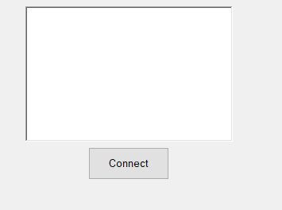 1. using System;

2. using System.Collections.Generic;

3. using System.ComponentModel;

4. using System.Data;

5. using System.Drawing;

6. using System.Linq;

7. using System.Text;

8. using System.Threading.Tasks;

9. using System.Windows.Forms;

10. using System.Runtime.InteropServices;

11. using LockheedMartin.Prepar3D.SimConnect;

12. using System.Speech.Recognition;

13. using System.Speech.Synthesis;

14.

15. namespace Sual94

16. {

17. public partial class Form1 : Form

18. {

19. const int WM_USER_SIMCONNECT = 0x0402;

20. SimConnect simconnect = null;

21. SpeechSynthesizer synth = new SpeechSynthesizer();

22. SpeechRecognitionEngine engine1 = new SpeechRecognitionEngine();

23. protected override void DefWndProc(ref Message m)

24. {

25. if (m.Msg == WM_USER_SIMCONNECT)

26. {

27. if (simconnect != null)

28. {

29. simconnect.ReceiveMessage();

30. }

31. }

32. else

33. {

34. base.DefWndProc(ref m);

35. }

36. }

37. enum EVENT_CTRL1

38. {

39. SITUATION_RESET,

40. }

41. enum GROUP_IDS

42. {

43. GROUP_1,

44. }

45. public Form1()

46. {

47. InitializeComponent();

48. }

49.

50. private void Form1_Load(object sender, EventArgs e)

51. {

52. engine1.SetInputToDefaultAudioDevice();

53. Choices ch1 = new Choices();

54. ch1.Add(new string[] { "restart" });

55. GrammarBuilder GB1 = new GrammarBuilder();

56. GB1.Append(ch1);

57. Grammar g = new Grammar(GB1);

58. engine1.LoadGrammarAsync(g);

59. engine1.SpeechRecognized += Engine1_SpeechRecognized;

60. engine1.RecognizeAsync(RecognizeMode.Multiple);

61. }

62. private void Engine1_SpeechRecognized(object sender, SpeechRecognizedEventArgs e)

63. {

64. string command = e.Result.Text;

65. if (e.Result.Text == "restart")

66. {

67. simconnect.TransmitClientEvent(0, EVENT_CTRL1.SITUATION_RESET, 1, GROUP_IDS.GROUP_1, SIMCONNECT_EVENT_FLAG.GROUPID_IS_PRIORITY);

68. }

69. }

70. private void Connectbutton_Click(object sender, EventArgs e)

71. {

72. if (simconnect == null)

73. {

74. try

75. {

76. simconnect = new SimConnect("Managed Data Request", this.Handle, WM_USER_SIMCONNECT, null, 0);

77. CinitDataRequest();

78. richTextBox1.Text += "Connected";

79. }

80. catch (COMException ex)

81. {

82. richTextBox1.Text += "Unable to connect to Prepar3D: \n\n" + ex.Message;

83. }

84. }

85. else

86. {

87. simconnect.Dispose();

88. simconnect = null;

89. richTextBox1.Text += "Connection closed \n";

90. }

91. }

92. private void CinitDataRequest()

93. {

94. try

95. {

96. simconnect.MapClientEventToSimEvent(EVENT_CTRL1.SITUATION_RESET, "SITUATION_RESET");

97.

98. }

99. catch (COMException ex)

100. {

101. richTextBox1.Text = richTextBox1.Text + ex.Message;

102. }

103. }

104. }

105. }

1. Hava gəmisinin kren bucağının 30 dərəcədən artıq olması barədə səs xəbərdarlığı proqram təminatının hazırlanması
2. C# -da “Button” komponentinə klik etməklə, Prepar3D aviasimulyatorunda gündüz və gecə rejimlərinə keçid

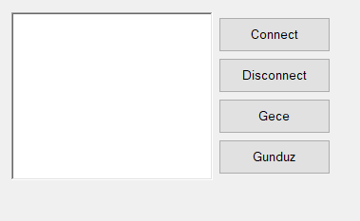 1. using System;

2. using System.Collections.Generic;

3. using System.ComponentModel;

4. using System.Data;

5. using System.Drawing;

6. using System.Linq;

7. using System.Text;

8. using System.Threading.Tasks;

9. using System.Windows.Forms;

10. using LockheedMartin.Prepar3D.SimConnect;

11. using System.Runtime.InteropServices;

12.

13. namespace Sual96

14. {

15. public partial class Form1 : Form

16. {

17. SimConnect simconnect = null;

18. const int WM_USER_SIMCONNECT = 0x0402;

19. double a, b;

20. enum EVENT_CTRL1

21. {

22. ZULU_HOURS_SET, KEY_ZULU_DAY_SET,

23. }

24. enum GROUP_IDS

25. {

26. GROUP_1,

27. }

28. private void closeConnection()

29. {

30. if (simconnect != null)

31. {

32. simconnect.Dispose();

33. simconnect = null;

34. richTextBox1.Text = richTextBox1.Text + "Connection Closed\n";

35. }

36. }

37. public Form1()

38. {

39. InitializeComponent();

40. }

41.

42. private void Disconnectbutton_Click(object sender, EventArgs e)

43. {

44. closeConnection();

45. }

46.

47. private void Connectbutton_Click(object sender, EventArgs e)

48. {

49. if (simconnect == null)

50. {

51. try

52. {

53. simconnect = new SimConnect("Sim1", this.Handle, WM_USER_SIMCONNECT, null, 0);

54. richTextBox1.Text = richTextBox1.Text + "Connected To P3D \n";

55. CinitDataRequest();

56. }

57. catch (COMException ex)

58. {

59. richTextBox1.Text = richTextBox1.Text + "Unable to connect to Prepar3D:\n\n" + ex.Message;

60. }

61. }

62. else

63. {

64. closeConnection();

65. }

66. }

67.

68. private void Gecebutton_Click(object sender, EventArgs e)

69. {

70. simconnect.TransmitClientEvent(0, EVENT_CTRL1.ZULU_HOURS_SET, 1, GROUP_IDS.GROUP_1, SIMCONNECT_EVENT_FLAG.GROUPID_IS_PRIORITY);

71. }

72.

73. private void Gunduzbutton_Click(object sender, EventArgs e)

74. {

75. simconnect.TransmitClientEvent(0, EVENT_CTRL1.ZULU_HOURS_SET, 0, GROUP_IDS.GROUP_1, SIMCONNECT_EVENT_FLAG.GROUPID_IS_PRIORITY);

76. }

77.

78. private void CinitDataRequest()

79. {

80. try

81. {

82. simconnect.MapClientEventToSimEvent(EVENT_CTRL1.ZULU_HOURS_SET, "ZULU_HOURS_SET");

83. }

84. catch (COMException ex)

85. {

86. richTextBox1.Text = richTextBox1.Text + ex.Message;

87. }

88. }

89. }

90. }

1. 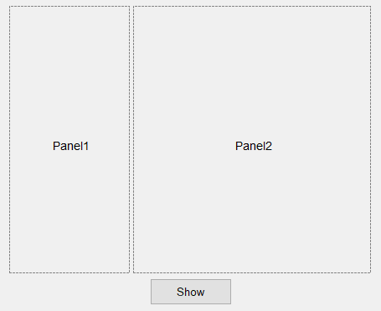Xəritə üzərində “Heydər Əliyev” Adına beynəlxalq hava limanın əks olunması (C#)

1. using System;

2. using System.Collections.Generic;

3. using System.ComponentModel;

4. using System.Data;

5. using System.Drawing;

6. using System.Linq;

7. using System.Text;

8. using System.Threading.Tasks;

9. using System.Windows.Forms;

10. using GMap.NET;

11. using GMap.NET.MapProviders;

12. using GMap.NET.WindowsForms;

13. using GMap.NET.WindowsForms.Markers;

14. using LockheedMartin.Prepar3D.SimConnect;

15. using System.Runtime.InteropServices;

16.

17. namespace Sual97

18. {

19. public partial class Form1 : Form

20. {

21. GMap.NET.WindowsForms.GMapControl gmap1;

22. const int WM_USER_SIMCONNECT = 0x0402;

23. SimConnect simconnect = null;

24. public Form1()

25. {

26. InitializeComponent();

27. gmap1 = new GMap.NET.WindowsForms.GMapControl();

28. gmap1.MapProvider = GMap.NET.MapProviders.GMapProviders.GoogleMap;

29. gmap1.Dock = DockStyle.Fill;

30. gmap1.MapProvider = GMap.NET.MapProviders.BingMapProvider.Instance;

31. GMap.NET.GMaps.Instance.Mode = GMap.NET.AccessMode.ServerAndCache;

32. gmap1.ShowCenter = false;

33. gmap1.MinZoom = 1;

34. gmap1.MaxZoom = 100;

35. splitContainer1.Panel2.Controls.Add(gmap1);

36. }

37.

38. private void Form1_Load(object sender, EventArgs e)

39. {

40. gmap1.MapProvider = GMapProviders.GoogleMap;

41. gmap1.MinZoom = 1;

42. gmap1.MaxZoom = 100;

43. }

44.

45. private void Showbutton_Click(object sender, EventArgs e)

46. {

47. gmap1.MapProvider = GMapProviders.GoogleMap;

48. gmap1.Position = new PointLatLng(40.4621702, 50.0476047);

49. gmap1.MinZoom = 1;

50. gmap1.MaxZoom = 100;

51. gmap1.Zoom = 15;

52. }

53. }

54. }

1. Verilənlər bazasından əldə edilmiş GPS koordinatların 2 saniyə intervalla xəritədə əks olunması
2. 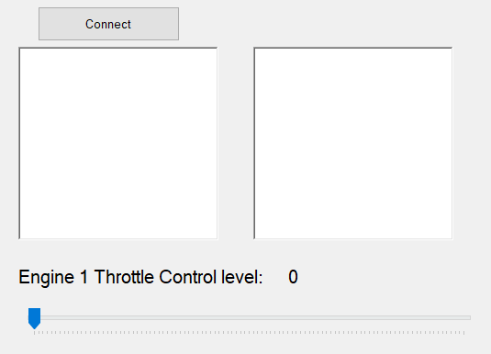Mooney Bravo tipli hava gəmisinin Throttle qurğusunun basılma dərəcəsinin real zaman şəraitində C#-da əks olunması (trackbar komponentində)

1. using System;

2. using System.Collections.Generic;

3. using System.ComponentModel;

4. using System.Data;

5. using System.Drawing;

6. using System.Linq;

7. using System.Text;

8. using System.Threading.Tasks;

Timer var

9. using System.Windows.Forms;

10. using LockheedMartin.Prepar3D.SimConnect;

11. using System.Runtime.InteropServices;

12. using static System.Windows.Forms.VisualStyles.VisualStyleElement;

13. using System.Reflection.Emit;

14. namespace Sual99

15. {

16. public partial class Form1 : Form

17. {

18. const int WM_USER_SIMCONNECT = 0x0402;

19. SimConnect simconnect = null;

20. public Form1()

21. {

22. InitializeComponent();

23. }

24. enum DEFINITIONS

25. {

26. Struct1,

27. }

28. enum DATA_REQUEST

29. {

30. REQUEST_1,

31. };

32. protected override void DefWndProc(ref Message m)

33. {

34. if (m.Msg == WM_USER_SIMCONNECT)

35. {

36. if (simconnect != null)

37. {

38. simconnect.ReceiveMessage();

39. }

40. }

41. else

42. {

43. base.DefWndProc(ref m);

44. }

45. }

46. private void Connectbutton_Click(object sender, EventArgs e)

47. {

48. timer1.Enabled = true;

49. if (simconnect == null)

50. {

51. try

52. {

53. simconnect = new SimConnect("Managed Data Request", this.Handle, WM_USER_SIMCONNECT, null, 0);

54. initDataRequest();

55. richTextBox1.Text = "Connected";

56. }

57. catch (COMException ex)

58. {

59. richTextBox1.Text = "Unable to connect to Prepar3D:\n\n" + ex.Message;

60. }

61. }

62. else

63. {

64. simconnect.Dispose();

65. simconnect = null;

66. richTextBox1.Text = "Connection closed";

67. }

68. }

69.

70. private void timer1_Tick(object sender, EventArgs e)

71. {

72. label2.Text = trackbar_throttle.Value.ToString();

73. simconnect.RequestDataOnSimObjectType(DATA_REQUEST.REQUEST_1, DEFINITIONS.Struct1, 0, SIMCONNECT_SIMOBJECT_TYPE.USER);

74. }

75. [StructLayout(LayoutKind.Sequential, CharSet = CharSet.Ansi, Pack = 1)]

76. struct Struct1

77. {

78. [MarshalAs(UnmanagedType.ByValTStr, SizeConst = 256)]

79. public String title;

80. public double GENERAL_ENG_THROTTLE_LEVER_POSITION;

81. };

82. private void initDataRequest()

83. {

84. try

85. {

86. simconnect.AddToDataDefinition(DEFINITIONS.Struct1, "Title", null, SIMCONNECT_DATATYPE.STRING256, 0.0f, SimConnect.SIMCONNECT_UNUSED);

87. simconnect.AddToDataDefinition(DEFINITIONS.Struct1, "GENERAL ENG THROTTLE LEVER POSITION:1", "percent", SIMCONNECT_DATATYPE.FLOAT64, 0.0f, SimConnect.SIMCONNECT_UNUSED);

88. simconnect.RegisterDataDefineStruct<Struct1>(DEFINITIONS.Struct1);

89. simconnect.OnRecvSimobjectDataBytype += new SimConnect.RecvSimobjectDataBytypeEventHandler(simconnect_Onreceivedata);

90. }

91. catch (COMException ex)

92. {

93. richTextBox2.Text = "ex.Message";

94. }

95. }

96. void simconnect_Onreceivedata(SimConnect sender, SIMCONNECT_RECV_SIMOBJECT_DATA_BYTYPE data)

97. {

98. switch ((DATA_REQUEST)data.dwRequestID)

99. {

100. case DATA_REQUEST.REQUEST_1:

101. Struct1 s1 = (Struct1)data.dwData[0];

102. richTextBox2.Text = "Title: " + s1.title + "\n";

103. richTextBox2.Text += "Throttle: " + s1.GENERAL_ENG_THROTTLE_LEVER_POSITION + "\n";

104. trackbar_throttle.Value = Convert.ToInt32(s1.GENERAL_ENG_THROTTLE_LEVER_POSITION);

105. break;

106.

107. default:

108. richTextBox2.Text = "Unknown request ID: " + data.dwRequestID;

109. break;

110. }

111. }

112. }

113. }

1. Hava gəmisinin cari mövqeyinin xəritə üzərində əks olunması
2. C#-da “TrackBar” komponenti vastəsilə Prepar3D –də Mooney Bravo modelində “Mixture” – basılma dərəcəsinin təyin edilməsi

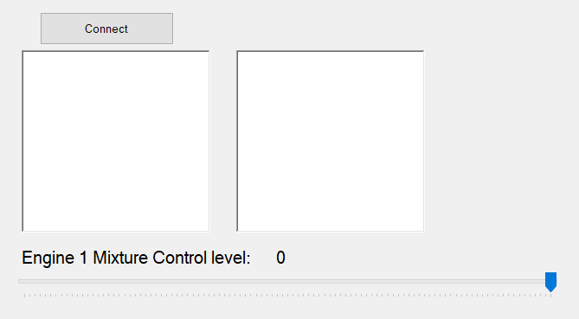 1. using System;

Timer var

2. using System.Collections.Generic;

3. using System.ComponentModel;

4. using System.Data;

5. using System.Drawing;

6. using System.Linq;

7. using System.Text;

8. using System.Threading.Tasks;

9. using System.Windows.Forms;

10. using LockheedMartin.Prepar3D.SimConnect;

11. using System.Runtime.InteropServices;

12.

13. namespace Sual101

14. {

15. public partial class Form1 : Form

16. {

17. const int WM_USER_SIMCONNECT = 0x0402;

18. SimConnect simconnect = null;

19. public Form1()

20. {

21. InitializeComponent();

22. }

23. enum DEFINITIONS

24. {

25. Struct1,

26. }

27. enum DATA_REQUEST

28. {

29. REQUEST_1,

30. };

31. enum EVENT_CTRL1

32. {

33. MIXTURE_SET,

34. }

35. enum GROUP_IDS

36. {

37. GROUP_1,

38. }

39. protected override void DefWndProc(ref Message m)

40. {

41. if (m.Msg == WM_USER_SIMCONNECT)

42. {

43. if (simconnect != null)

44. {

45. simconnect.ReceiveMessage();

46. }

47. }

48. else

49. {

50. base.DefWndProc(ref m);

51. }

52. }

53. private void Connectbutton_Click(object sender, EventArgs e)

54. {

55. timer1.Enabled = true;

56. if (simconnect == null)

57. {

58. try

59. {

60. simconnect = new SimConnect("Managed Data Request", this.Handle, WM_USER_SIMCONNECT, null, 0);

61. CinitDataRequest();

62. initDataRequest();

63. richTextBox1.Text = "Connected";

64. }

65. catch (COMException ex)

66. {

67. richTextBox1.Text = "Unable to connect to Prepar3D:\n\n" + ex.Message;

68. }

69. }

70. else

71. {

72. simconnect.Dispose();

73. simconnect = null;

74. richTextBox1.Text = "Connection closed";

75. }

76. }

77.

78. private void timer1_Tick(object sender, EventArgs e)

79. {

80. label4.Text = trackBar_Mix.Value.ToString();

81. simconnect.RequestDataOnSimObjectType(DATA_REQUEST.REQUEST_1, DEFINITIONS.Struct1, 0, SIMCONNECT_SIMOBJECT_TYPE.USER);

82. simconnect.SetDataOnSimObject(DEFINITIONS.Struct1, SimConnect.SIMCONNECT_OBJECT_ID_USER, SIMCONNECT_DATA_SET_FLAG.DEFAULT, new Struct1 { GENERAL_ENG_MIXTURE_LEVER_POSITION = trackBar_Mix.Value });

83. }

84. [StructLayout(LayoutKind.Sequential, CharSet = CharSet.Ansi, Pack = 1)]

85. struct Struct1

86. {

87. public double GENERAL_ENG_MIXTURE_LEVER_POSITION;

88. };

89. private void CinitDataRequest()

90. {

91. try

92. {

93. simconnect.MapClientEventToSimEvent(EVENT_CTRL1.MIXTURE_SET, "MIXTURE_SET");

94. }

95. catch (COMException ex)

96. {

97. richTextBox1.Text = richTextBox1.Text + ex.Message;

98. }

99. }

100. private void initDataRequest()

101. {

102. try

103. {

104. simconnect.AddToDataDefinition(DEFINITIONS.Struct1, "GENERAL ENG MIXTURE LEVER POSITION:1", "percent", SIMCONNECT_DATATYPE.FLOAT64, 0.0f, SimConnect.SIMCONNECT_UNUSED);

105. simconnect.RegisterDataDefineStruct<Struct1>(DEFINITIONS.Struct1);

106. simconnect.OnRecvSimobjectDataBytype += new SimConnect.RecvSimobjectDataBytypeEventHandler(simconnect_Onreceivedata);

107. }

108. catch (COMException ex)

109. {

110. richTextBox2.Text = "ex.Message";

111. }

112. }

113. void simconnect_Onreceivedata(SimConnect sender, SIMCONNECT_RECV_SIMOBJECT_DATA_BYTYPE data)

114. {

115. switch ((DATA_REQUEST)data.dwRequestID)

116. {

117. case DATA_REQUEST.REQUEST_1:

118. Struct1 s1 = (Struct1)data.dwData[0];

119. richTextBox2.Text = "Mixture: " + s1.GENERAL_ENG_MIXTURE_LEVER_POSITION;

120. //trackBar_Mix.Value = Convert.ToInt32(s1.GENERAL_ENG_MIXTURE_LEVER_POSITION);

121. break;

122.

123. default:

124. richTextBox2.Text = "Unknown request ID: " + data.dwRequestID;

125. break;

126. }

127. }

128. }

129. }

1. 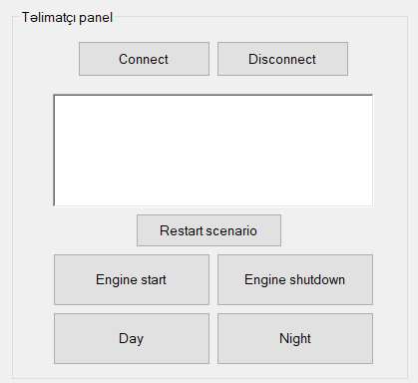Təlimatçı panelini imitasiya edən proqram təminatının hazırlanması

1. using System;

2. using System.Collections.Generic;

3. using System.ComponentModel;

4. using System.Data;

5. using System.Drawing;

6. using System.Linq;

7. using System.Text;

8. using System.Threading.Tasks;

9. using System.Windows.Forms;

10. using LockheedMartin.Prepar3D.SimConnect;

11. using System.Runtime.InteropServices;

12.

13. namespace Sual102

14. {

15. public partial class Form1 : Form

16. {

17. SimConnect simconnect = null;

18. const int WM_USER_SIMCONNECT = 0x0402;

19. double a, b;

20. protected override void DefWndProc(ref Message m)

21. {

22. if (m.Msg == WM_USER_SIMCONNECT)

23. {

24. if (simconnect != null)

25. {

26. simconnect.ReceiveMessage();

27. }

28. }

29. else

30. {

31. base.DefWndProc(ref m);

32. }

33. }

34. enum EVENT_CTRL1

35. {

36. ZULU_HOURS_SET, KEY_ZULU_DAY_SET, SITUATION_RESET, ENGINE_AUTO_START, ENGINE_AUTO_SHUTDOWN,

37. }

38. enum GROUP_IDS

39. {

40. GROUP_1,

41. }

42. private void closeConnection()

43. {

44. if (simconnect != null)

45. {

46. simconnect.Dispose();

47. simconnect = null;

48. richTextBox1.Text = "Connection Closed\n";

49. }

50. }

51. public Form1()

52. {

53. InitializeComponent();

54. }

55.

56. private void Disconnectbutton_Click(object sender, EventArgs e)

57. {

58. closeConnection();

59. }

60.

61. private void Nightbutton_Click(object sender, EventArgs e)

62. {

63. simconnect.TransmitClientEvent(0, EVENT_CTRL1.ZULU_HOURS_SET, 1, GROUP_IDS.GROUP_1, SIMCONNECT_EVENT_FLAG.GROUPID_IS_PRIORITY);

64. }

65.

66. private void Daybutton_Click(object sender, EventArgs e)

67. {

68. simconnect.TransmitClientEvent(0, EVENT_CTRL1.ZULU_HOURS_SET, 0, GROUP_IDS.GROUP_1, SIMCONNECT_EVENT_FLAG.GROUPID_IS_PRIORITY);

69. }

70.

71. private void Connectbutton_Click(object sender, EventArgs e)

72. {

73. if (simconnect == null)

74. {

75. try

76. {

77. simconnect = new SimConnect("Sim1", this.Handle, WM_USER_SIMCONNECT, null, 0);

78. richTextBox1.Text = "Connected To P3D \n";

79. CinitDataRequest();

80. }

81. catch (COMException ex)

82. {

83. richTextBox1.Text = "Unable to connect to Prepar3D:\n\n" + ex.Message;

84. }

85. }

86. else

87. {

88. closeConnection();

89. }

90. }

91.

92. private void Restartbutton_Click(object sender, EventArgs e)

93. {

94. simconnect.TransmitClientEvent(0, EVENT_CTRL1.SITUATION_RESET, 1, GROUP_IDS.GROUP_1, SIMCONNECT_EVENT_FLAG.GROUPID_IS_PRIORITY);

95. }

96.

97. private void Shutdownbutton_Click(object sender, EventArgs e)

98. {

99. simconnect.TransmitClientEvent(0, EVENT_CTRL1.ENGINE_AUTO_SHUTDOWN, 1, GROUP_IDS.GROUP_1, SIMCONNECT_EVENT_FLAG.GROUPID_IS_PRIORITY);

100. }

101.

102. private void Startbutton_Click(object sender, EventArgs e)

103. {

104. simconnect.TransmitClientEvent(0, EVENT_CTRL1.ENGINE_AUTO_START, 1, GROUP_IDS.GROUP_1, SIMCONNECT_EVENT_FLAG.GROUPID_IS_PRIORITY);

105. }

106.

107. private void CinitDataRequest()

108. {

109. try

110. {

111. simconnect.MapClientEventToSimEvent(EVENT_CTRL1.ZULU_HOURS_SET, "ZULU_HOURS_SET");

112. simconnect.MapClientEventToSimEvent(EVENT_CTRL1.SITUATION_RESET, "SITUATION_RESET");

113. simconnect.MapClientEventToSimEvent(EVENT_CTRL1.ENGINE_AUTO_START, "ENGINE_AUTO_START");

114. simconnect.MapClientEventToSimEvent(EVENT_CTRL1.ENGINE_AUTO_SHUTDOWN, "ENGINE_AUTO_SHUTDOWN");

115. }

116. catch (COMException ex)

117. {

118. richTextBox1.Text = richTextBox1.Text + ex.Message;

119. }

120. }

121. }

122. }

1. 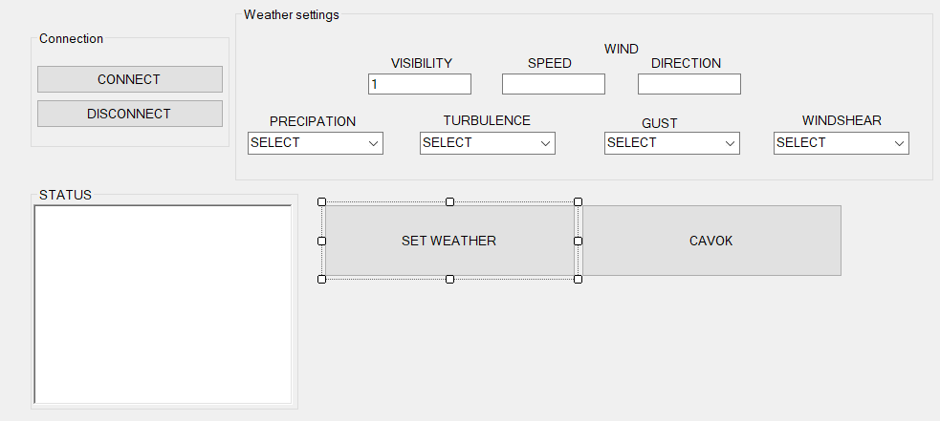Hava şəraitinin idarə olunması üçün proqram təminatının hazırlanması

1. using System;

2. using System.Collections.Generic;

3. using System.ComponentModel;

4. using System.Data;

5. using System.Drawing;

6. using System.Linq;

7. using System.Runtime.InteropServices;

8. using System.Text;

9. using System.Threading.Tasks;

10. using System.Windows.Forms;

11. using LockheedMartin.Prepar3D.SimConnect;

12. using System.Runtime.InteropServices;

13. using System.Diagnostics;

14.

15. namespace Sual103

16. {

17. public partial class Form1 : Form

18. {

19. const int WM_USER_SIMCONNECT = 0x0402;

20. SimConnect simconnect = null;

21. public Form1()

22. {

23. InitializeComponent();

24. }

25.

26. private void Connectbutton_Click(object sender, EventArgs e)

27. {

28. if (simconnect == null)

29. {

30. try

31. {

32. simconnect = new SimConnect("Managed Data Request", this.Handle, WM_USER_SIMCONNECT, null, 0);

33. richTextBox1.Text += "Connected to Prepar3D\n";

34. }

35. catch (COMException ex)

36. {

37. richTextBox1.Text += Environment.NewLine + "Error - try again";

38. closeConnection();

39. }

40. }

41. }

42. private void Disconnectbutton_Click(object sender, EventArgs e)

43. {

44. closeConnection();

45. }

46. private void closeConnection()

47. {

48. if (simconnect != null)

49. {

50. simconnect.Dispose();

51. simconnect = null;

52. richTextBox1.Text = "Connection closed";

53. }

54. }

55. private void Cavokbutton_Click(object sender, EventArgs e)

56. {

57. simconnect.WeatherSetObservation(1, "GLOB CAVOK");

58. simconnect.WeatherSetModeCustom();

59. simconnect.WeatherSetModeGlobal();

60. }

61.

62. private void SetWeatherbutton_Click(object sender, EventArgs e)

63. {

64. if (wspeed.Text == "")

65. {

66. wspeed.Text = "0";

67. wdirection.Text = "0";

68. }

69. //Kill all on screen keyboards

70. Process[] oskProcessArray = Process.GetProcessesByName("TabTip");

71. foreach (Process onscreenProcess in oskProcessArray)

72. {

73. onscreenProcess.Kill();

74. }

75. string prec = "", turb = "", wshear = "G", gust = "", gustspeed = "";

76. //turbulence

77. if (comboBox_turb.Text == "NONE")

78. turb = "N";

79. if (comboBox_turb.Text == "LIGHT")

80. turb = "L";

81. if (comboBox_turb.Text == "MODERATE")

82. turb = "M";

83. if (comboBox_turb.Text == "HEAVY")

84. turb = "H";

85. if (comboBox_turb.Text == "SEVER")

86. turb = "S";

87. //precipitation

88. if (comboBox_prec.Text == "NONE")

89. prec = "";

90. if (comboBox_prec.Text == "SNOW")

91. prec = "+SN";

92. if (comboBox_prec.Text == "RAIN")

93. prec = "+RA";

94. //windshear

95. if (comboBox_wshear.Text == "NONE")

96. wshear = "G";

97. if (comboBox_wshear.Text == "MODERATE")

98. wshear = "M";

99. if (comboBox_wshear.Text == "STEEP")

100. wshear = "S";

101. if (comboBox_wshear.Text == "INSTANTANEOUS")

102. wshear = "T";

103. if (wdirection.Text.Length < 2 & wdirection.Text.Length > 0)

104. wdirection.Text = "00" + wdirection.Text;

105. if (wdirection.Text.Length < 3 & wdirection.Text.Length > 0)

106. wdirection.Text = "0" + wdirection.Text;

107. if (wspeed.Text.Length < 2 & wspeed.Text.Length > 0)

108. wspeed.Text = "0" + wspeed.Text;

109. simconnect.WeatherSetModeGlobal();

110. simconnect.WeatherSetObservation(1, "GLOB 030405Z" + " " + wdirection.Text + wspeed.Text + "KT&D5800" + turb + wshear + " " + visibilty.Text + "SM" + " " + prec + " " + "BKN262 M10/ 00 A2992");

111. }

112. }

113. }

1. 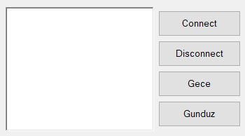Gecə və gündüz rejimlərinə keçid edən proqram təminatının hazırlanması

1. using System;

2. using System.Collections.Generic;

3. using System.ComponentModel;

4. using System.Data;

5. using System.Drawing;

6. using System.Linq;

7. using System.Text;

8. using System.Threading.Tasks;

9. using System.Windows.Forms;

10. using LockheedMartin.Prepar3D.SimConnect;

11. using System.Runtime.InteropServices;

12.

13. namespace Sual104

14. {

15. public partial class Form1 : Form

16. {

17. SimConnect simconnect = null;

18. const int WM_USER_SIMCONNECT = 0x0402;

19. double a, b;

20. enum EVENT_CTRL1

21. {

22. ZULU_HOURS_SET, KEY_ZULU_DAY_SET,

23. }

24. enum GROUP_IDS

25. {

26. GROUP_1,

27. }

28. private void closeConnection()

29. {

30. if (simconnect != null)

31. {

32. simconnect.Dispose();

33. simconnect = null;

34. richTextBox1.Text = richTextBox1.Text + "Connection Closed\n";

35. }

36. }

37. public Form1()

38. {

39. InitializeComponent();

40. }

41. private void Disconnectbutton_Click(object sender, EventArgs e)

42. {

43. closeConnection();

44. }

45. private void Connectbutton_Click(object sender, EventArgs e)

46. {

47. if (simconnect == null)

48. {

49. try

50. {

51. simconnect = new SimConnect("Sim1", this.Handle, WM_USER_SIMCONNECT, null, 0);

52. richTextBox1.Text = richTextBox1.Text + "Connected To P3D \n";

53. CinitDataRequest();

54. }

55. catch (COMException ex)

56. {

57. richTextBox1.Text = richTextBox1.Text + "Unable to connect to Prepar3D:\n\n" + ex.Message;

58. }

59. }

60. else

61. {

62. closeConnection();

63. }

64. }

65. private void Gecebutton_Click(object sender, EventArgs e)

66. {

67. simconnect.TransmitClientEvent(0, EVENT_CTRL1.ZULU_HOURS_SET, 1, GROUP_IDS.GROUP_1, SIMCONNECT_EVENT_FLAG.GROUPID_IS_PRIORITY);

68. }

69. private void Gunduzbutton_Click(object sender, EventArgs e)

70. {

71. simconnect.TransmitClientEvent(0, EVENT_CTRL1.ZULU_HOURS_SET, 0, GROUP_IDS.GROUP_1, SIMCONNECT_EVENT_FLAG.GROUPID_IS_PRIORITY);

72. }

73. private void CinitDataRequest()

74. {

75. try

76. {

77. simconnect.MapClientEventToSimEvent(EVENT_CTRL1.ZULU_HOURS_SET, "ZULU_HOURS_SET");

78. }

79. catch (COMException ex)

80. {

81. richTextBox1.Text = richTextBox1.Text + ex.Message;

82. }

83. }

84. }

85. }

1. Aviasimulyatorda küləyin sürəti və istiqamətinin idarə olunması üçün proqram təminatının hazırlanması

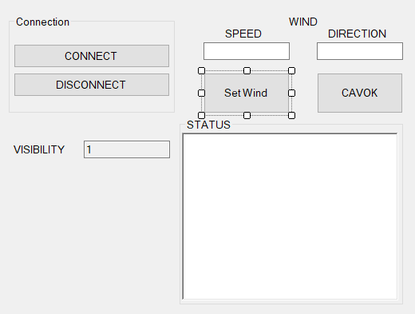 1. using System;

2. using System.Collections.Generic;

3. using System.ComponentModel;

4. using System.Data;

5. using System.Drawing;

6. using System.Linq;

7. using System.Text;

8. using System.Threading.Tasks;

9. using System.Windows.Forms;

10. using LockheedMartin.Prepar3D.SimConnect;

11. using System.Runtime.InteropServices;

12. using System.Diagnostics;

13.

14. namespace Sual105

15. {

16. public partial class Form1 : Form

17. {

18. const int WM_USER_SIMCONNECT = 0x0402;

19. SimConnect simconnect = null;

20. public Form1()

21. {

22. InitializeComponent();

23. }

24.

25. private void Connectbutton_Click(object sender, EventArgs e)

26. {

27. if (simconnect == null)

28. {

29. try

30. {

31. simconnect = new SimConnect("Managed Data Request", this.Handle, WM_USER_SIMCONNECT, null, 0);

32. richTextBox1.Text += "Connected to Prepar3D\n";

33. }

34. catch (COMException ex)

35. {

36. richTextBox1.Text += Environment.NewLine + "Error - try again";

37. closeConnection();

38. }

39. }

40. }

41.

42. private void Disconnectbutton_Click(object sender, EventArgs e)

43. {

44. closeConnection();

45. }

46. private void closeConnection()

47. {

48. if (simconnect != null)

49. {

50. simconnect.Dispose();

51. simconnect = null;

52. richTextBox1.Text = "Connection closed";

53. }

54. }

55. private void Cavokbutton_Click(object sender, EventArgs e)

56. {

57. simconnect.WeatherSetObservation(1, "GLOB CAVOK");

58. simconnect.WeatherSetModeCustom();

59. simconnect.WeatherSetModeGlobal();

60. }

61.

62. private void SetWindbutton_Click(object sender, EventArgs e)

63. {

64. if (string.IsNullOrEmpty(wspeed.Text))

65. {

66. wspeed.Text = "0";

67. }

68. if (string.IsNullOrEmpty(wdirection.Text))

69. {

70. wdirection.Text = "0";

71. }

72.

73. // İstiqamət və sürəti düzgün formatlamaq üçün sıfır əlavə edin

74. if (wdirection.Text.Length < 2)

75. wdirection.Text = wdirection.Text.PadLeft(3, '0');

76. if (wspeed.Text.Length < 2)

77. wspeed.Text = wspeed.Text.PadLeft(2, '0');

78.

79. try

80. {

81. // SimConnect vasitəsilə külək parametrlərini yeniləyin

82. simconnect.WeatherSetModeGlobal();

83. simconnect.WeatherSetObservation(1, $"GLOB 030405Z {wdirection.Text}{wspeed.Text}KT");

84. }

85. catch (Exception ex)

86. {

87. MessageBox.Show($"Külək dəyişdirilərkən xəta baş verdi: {ex.Message}");

88. }

89. }

90. }

91. }

92.

1. 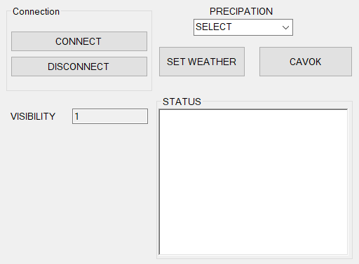Yağış və qarlı hava şəraitinin idarə olunması üçün proqram təminatının hazırlanması

1. using System;

2. using System.Collections.Generic;

3. using System.ComponentModel;

4. using System.Data;

5. using System.Drawing;

6. using System.Linq;

7. using System.Text;

8. using System.Threading.Tasks;

9. using System.Windows.Forms;

10. using LockheedMartin.Prepar3D.SimConnect;

11. using System.Runtime.InteropServices;

12. using System.Diagnostics;

13.

14. namespace Sual106

15. {

16. public partial class Form1 : Form

17. {

18. const int WM_USER_SIMCONNECT = 0x0402;

19. SimConnect simconnect = null;

20. public Form1()

21. {

22. InitializeComponent();

23. }

24.

25. private void Form1_Load(object sender, EventArgs e)

26. {

27.

28. }

29.

30. private void Connectbutton_Click(object sender, EventArgs e)

31. {

32. if (simconnect == null)

33. {

34. try

35. {

36. simconnect = new SimConnect("Managed Data Request", this.Handle, WM_USER_SIMCONNECT, null, 0);

37. richTextBox1.Text += "Connected to Prepar3D\n";

38. }

39. catch (COMException ex)

40. {

41. richTextBox1.Text += Environment.NewLine + "Error - try again";

42. closeConnection();

43. }

44. }

45. }

46. private void Disconnectbutton_Click(object sender, EventArgs e)

47. {

48. closeConnection();

49. }

50. private void closeConnection()

51. {

52. if (simconnect != null)

53. {

54. simconnect.Dispose();

55. simconnect = null;

56. richTextBox1.Text = "Connection closed";

57. }

58. }

59.

60. private void SetWeatherbutton_Click(object sender, EventArgs e)

61. {

62. // Əgər yağıntı seçilməyibsə, default NONE təyin edin

63. string precipitationType = comboBox_prec.Text.ToUpper();

64. if (string.IsNullOrEmpty(precipitationType))

65. {

66. precipitationType = "NONE";

67. }

68. // Yağıntı növünü təyin edin

69. string prec = "";

70. switch (precipitationType)

71. {

72. case "NONE":

73. prec = "";

74. break;

75. case "SNOW":

76. prec = "+SN";

77. break;

78. case "RAIN":

79. prec = "+RA";

80. break;

81. default:

82. MessageBox.Show("Naməlum yağıntı növü seçildi.");

83. return;

84. }

85.

86. try

87. {

88. // Hava rejimini qlobal olaraq təyin edin

89. simconnect.WeatherSetModeGlobal();

90.

91. // Müşahidə məlumatını hava şəraitinə tətbiq edin

92. string observation = $"GLOB 030405Z 00000KT 10SM {prec} BKN262 M10/00 A2992";

93. simconnect.WeatherSetObservation(1, observation);

94. }

95. catch (Exception ex)

96. {

97. MessageBox.Show($"Hava şəraiti dəyişdirilə bilmədi: {ex.Message}");

98. }

99. }

100.

101. private void Cavokbutton_Click_1(object sender, EventArgs e)

102. {

103. simconnect.WeatherSetObservation(1, "GLOB CAVOK");

104. simconnect.WeatherSetModeCustom();

105. simconnect.WeatherSetModeGlobal();

106. }

107. }

108. }

1. Mühərrikin dövrlər sayının real zaman şəraitində əks olunması

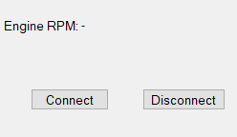 1. using System;

2. using System.Runtime.InteropServices;

3. using System.Windows.Forms;

4. using LockheedMartin.Prepar3D.SimConnect;

5.

6. namespace Sual107

7. {

8. public partial class Form1 : Form

9. {

10. private SimConnect simConnect = null;

11. private const int WM_USER_SIMCONNECT = 0x0402;

12. private enum DataRequest

13. {

14. Request_1

15. }

16. private struct EngineData

17. {

18. public double rpm;

19. }

20. public Form1()

21. {

22. InitializeComponent();

23. }

24. // Connect to Prepar3D

25. private void connectButton_Click(object sender, EventArgs e)

26. {

27. try

28. {

29. simConnect = new SimConnect("Mooney Bravo RPM Monitor", Handle, WM_USER_SIMCONNECT, null, 0);

30.

31. // Subscribe to Engine RPM data

32. simConnect.AddToDataDefinition(DataRequest.Request_1, "GENERAL ENG RPM:1", "rpm",

33. SIMCONNECT_DATATYPE.FLOAT64, 0.0f, SimConnect.SIMCONNECT_UNUSED);

34. simConnect.RegisterDataDefineStruct<EngineData>(DataRequest.Request_1);

35.

36. // Request data every second

37. simConnect.RequestDataOnSimObject(

38. DataRequest.Request_1,

39. DataRequest.Request_1,

40. SimConnect.SIMCONNECT_OBJECT_ID_USER,

41. SIMCONNECT_PERIOD.SECOND,

42. SIMCONNECT_DATA_REQUEST_FLAG.DEFAULT,

43. 0, 0, 0

44. );

46. rpmLabel.Text = "Connected to Prepar3D";

47. simConnect.OnRecvSimobjectData += SimConnect_OnRecvSimobjectData;

48. }

49. catch (Exception ex)

50. {

51. rpmLabel.Text = $"Connection Error: {ex.Message}";

52. }

53. }

54. // Disconnect from Prepar3D

55. private void disconnectButton_Click(object sender, EventArgs e)

56. {

57. if (simConnect != null)

58. {

59. simConnect.Dispose();

60. simConnect = null;

61. rpmLabel.Text = "Disconnected";

62. }

63. }

64. // Handle incoming SimConnect messages

65. protected override void WndProc(ref Message m)

66. {

67. if (m.Msg == WM_USER_SIMCONNECT)

68. {

69. simConnect?.ReceiveMessage();

70. }

71. base.WndProc(ref m);

72. }

73. // Receive data from SimConnect

74. private void SimConnect_OnRecvSimobjectData(SimConnect sender, SIMCONNECT_RECV_SIMOBJECT_DATA data)

75. {

76. if (data.dwRequestID == (uint)DataRequest.Request_1)

77. {

78. EngineData engineData = (EngineData)data.dwData[0];

79. rpmLabel.Text = $"Engine RPM: {engineData.rpm:F1}";

80. }

81. }

82. private void connectButton_Click_1(object sender, EventArgs e)

83. {

84. try

85. {

86. simConnect = new SimConnect("Mooney Bravo RPM Monitor", Handle, WM_USER_SIMCONNECT, null, 0);

87. // Subscribe to Engine RPM data

88. simConnect.AddToDataDefinition(DataRequest.Request_1, "GENERAL ENG RPM:1", "rpm",

89. SIMCONNECT_DATATYPE.FLOAT64, 0.0f, SimConnect.SIMCONNECT_UNUSED);

90. simConnect.RegisterDataDefineStruct<EngineData>(DataRequest.Request_1);

91. // Request data every second

92. simConnect.RequestDataOnSimObject(

93. DataRequest.Request_1,

94. DataRequest.Request_1,

95. SimConnect.SIMCONNECT_OBJECT_ID_USER,

96. SIMCONNECT_PERIOD.SECOND,

97. SIMCONNECT_DATA_REQUEST_FLAG.DEFAULT,

98. 0, 0, 0

99. );

100.

101. rpmLabel.Text = "Connected to Prepar3D";

102. simConnect.OnRecvSimobjectData += SimConnect_OnRecvSimobjectData;

103. }

104. catch (Exception ex)

105. {

106. rpmLabel.Text = $"Connection Error: {ex.Message}";

107. }

108. }

109. private void disconnectButton_Click_1(object sender, EventArgs e)

110. {

111. if (simConnect != null)

112. {

113. simConnect.Dispose();

114. simConnect = null;

115. rpmLabel.Text = "Disconnected";

116. }

117. }

118. private void rpmLabel_Click(object sender, EventArgs e)

119. {

120.

121. }

122. }

123. }

1. Verilənlər bazasında yerləşən aviasimulyator koordinatlarının xəritə üzərində əks olunması
2. 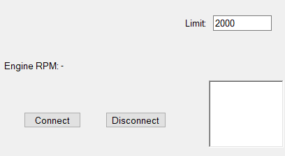Mühərrikin dövrlər sayının müəyyən həddə düşdükdən sonra səs xəbərdarlıq sisteminin imitasiyası

1. using System;

2. using System.Runtime.InteropServices;

3. using System.Windows.Forms;

4. using LockheedMartin.Prepar3D.SimConnect;

5. using System.Speech.Synthesis;

6. using System.Reflection.Emit;

7. using static System.Windows.Forms.VisualStyles.VisualStyleElement;

8.

9.

10. namespace Sual109

11. {

12. public partial class Form1 : Form

13. {

14. SimConnect simconnect = null;

15. SpeechSynthesizer synth = new SpeechSynthesizer();

16. private SimConnect simConnect = null;

17. private const int WM_USER_SIMCONNECT = 0x0402;

18. private enum DataRequest

19. {

20. Request_1

21. }

22. private struct EngineData

23. {

24. public double rpm;

25. }

26. public Form1()

27. {

28. InitializeComponent();

29. }

30. private void connectButton_Click(object sender, EventArgs e)

31. {

32. try

33. {

34. simConnect = new SimConnect("Mooney Bravo RPM Monitor", Handle, WM_USER_SIMCONNECT, null, 0);

35.

36. simConnect.AddToDataDefinition(DataRequest.Request_1, "GENERAL ENG RPM:1", "rpm",

37. SIMCONNECT_DATATYPE.FLOAT64, 0.0f, SimConnect.SIMCONNECT_UNUSED);

38. simConnect.RegisterDataDefineStruct<EngineData>(DataRequest.Request_1);

39. simConnect.RequestDataOnSimObject(

40. DataRequest.Request_1,

41. DataRequest.Request_1,

42. SimConnect.SIMCONNECT_OBJECT_ID_USER,

43. SIMCONNECT_PERIOD.SECOND,

44. SIMCONNECT_DATA_REQUEST_FLAG.DEFAULT,

45. 0, 0, 0

46. );

47. rpmLabel.Text = "Connected to Prepar3D";

48. simConnect.OnRecvSimobjectData += SimConnect_OnRecvSimobjectData;

49. }

50. catch (Exception ex)

51. {

52. rpmLabel.Text = $"Connection Error: {ex.Message}";

53. }

54. }

55. private void disconnectButton_Click(object sender, EventArgs e)

56. {

57. if (simConnect != null)

58. {

59. simConnect.Dispose();

60. simConnect = null;

61. rpmLabel.Text = "Disconnected";

62. }

63. }

64. protected override void WndProc(ref Message m)

65. {

66. if (m.Msg == WM_USER_SIMCONNECT)

67. {

68. simConnect?.ReceiveMessage();

69. }

70. base.WndProc(ref m);

71. }

72. private void SimConnect_OnRecvSimobjectData(SimConnect sender, SIMCONNECT_RECV_SIMOBJECT_DATA data)

73. {

74. if (data.dwRequestID == (uint)DataRequest.Request_1)

75. {

76. EngineData engineData = (EngineData)data.dwData[0];

77. rpmLabel.Text = $"Engine RPM: {engineData.rpm:F1}";

78. richTextBox1.Text = $" {engineData.rpm:F1}";

79. }

80. }

81. private void connectButton_Click_1(object sender, EventArgs e)

82. {

83. try

84. {

85. simConnect = new SimConnect("Mooney Bravo RPM Monitor", Handle, WM_USER_SIMCONNECT, null, 0);

86. simConnect.AddToDataDefinition(DataRequest.Request_1, "GENERAL ENG RPM:1", "rpm",

87. SIMCONNECT_DATATYPE.FLOAT64, 0.0f, SimConnect.SIMCONNECT_UNUSED);

88. simConnect.RegisterDataDefineStruct<EngineData>(DataRequest.Request_1);

89. simConnect.RequestDataOnSimObject(

90. DataRequest.Request_1,

91. DataRequest.Request_1,

92. SimConnect.SIMCONNECT_OBJECT_ID_USER,

93. SIMCONNECT_PERIOD.SECOND,

94. SIMCONNECT_DATA_REQUEST_FLAG.DEFAULT,

95. 0, 0, 0

96. );

97.

98. rpmLabel.Text = "Connected to Prepar3D";

99. simConnect.OnRecvSimobjectData += SimConnect_OnRecvSimobjectData;

100. }

101. catch (Exception ex)

102. {

103. rpmLabel.Text = $"Connection Error: {ex.Message}";

104. }

105. timer1.Enabled = true;

106. }

107. private void disconnectButton_Click_1(object sender, EventArgs e)

108. {

109. if (simConnect != null)

110. {

111. simConnect.Dispose();

112. simConnect = null;

113. rpmLabel.Text = "Disconnected";

114. }

115. }

116. private void timer1_Tick_1(object sender, EventArgs e)

117. {

118. if (Convert.ToDouble(textBox1.Text) > Convert.ToDouble(richTextBox1.Text))

119. {

120. synth.SpeakAsync("Warning");

121. }

122. }

123. }

124. }

125.

1. Hava gəmisinin avtomatik olaraq işə salınması və havaya qaldırılmasını təmin edən proqram təminatının hazırlanması